 | Autumn 1 | Autumn 2 | Spring 1 | Spring 2 | Summer 1 | Summer 2
Enhancements | Colours  Patterns  Making friends  Autumn changes | Animals  Height and weight  Feelings  Festivals/  celebrations | Vehicles/transport  Jobs – emergency services  Spring changes | Planting  Growing  Minibeasts  Healthy eating/ fruit/vegetables  Easter | Fairy tale characters  Traditional tales  Weather  Summer changes | Maps  Countries  Seaside  Under the sea
Focus Storybooks | Nursery Rhymes | 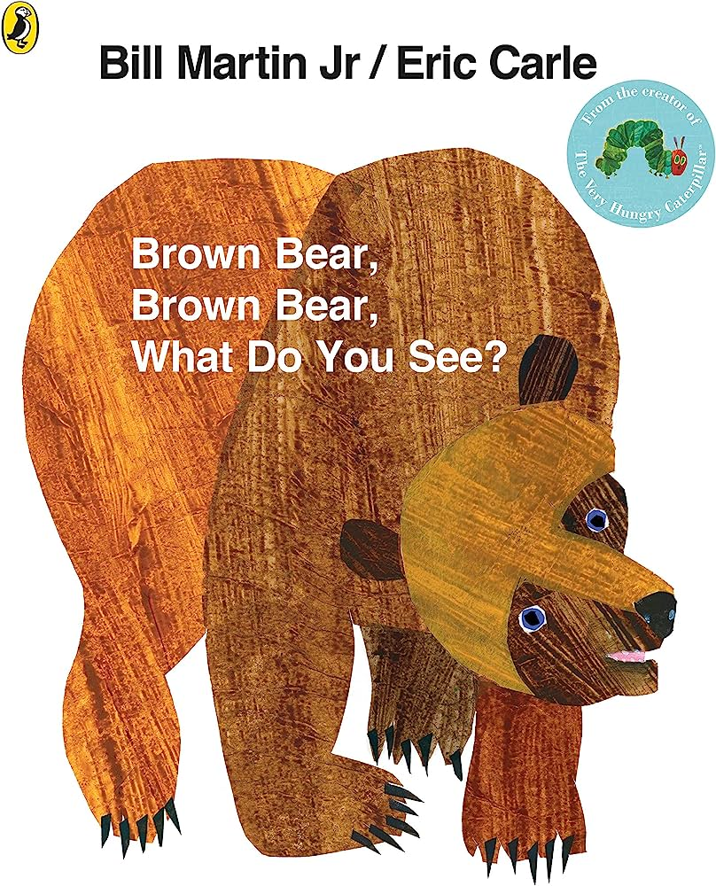  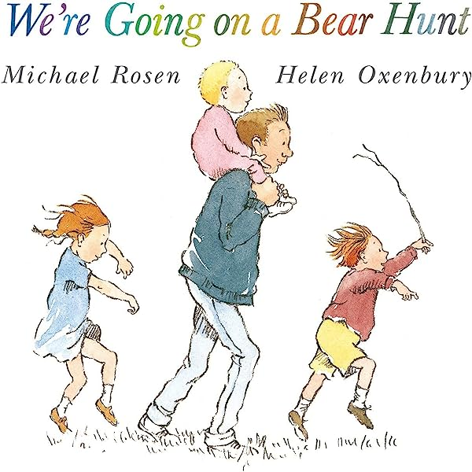 | 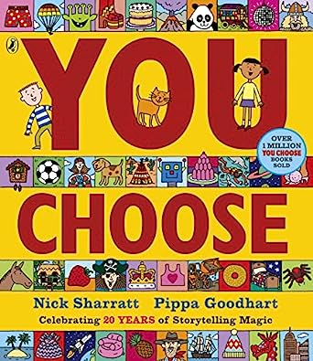 | 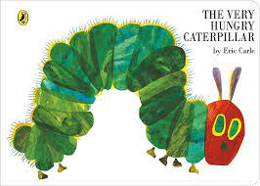  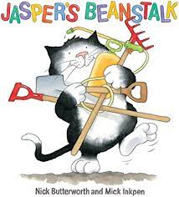 | 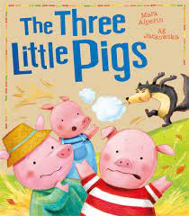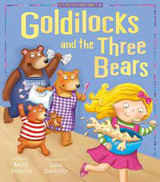  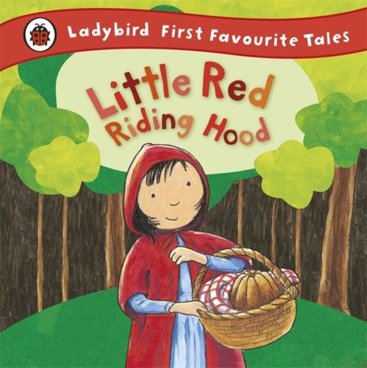 | 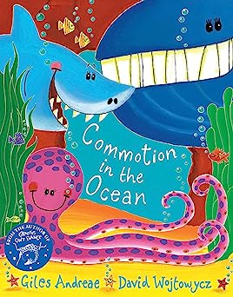
I wonder questions | What makes me, me?  Who is in my family?  Where do I live?  Who lives in my house? | What do you see?  How do we celebrate? | Who can help us?  What job would you like to do?  Who keeps us safe?  How do you travel? | What is growing in the garden?  What is a life cycle?  Where do butterflies come from?  How does a seed grow? | Who lived happily ever after?  What will you use to build a house?  Who lives in that house? | Who lives under the sea?
Focus vocabulary  See knowledge organisers | Different, family, home, routine, Nursery, autumn | Celebration, festival, season, winter | Emergency, help, job, safe, spring | Growing, seed, lifecycle, chrysalis, Easter | Big bad wolf, character, setting, plot, woodland, summer | Adventure, coral, seabed, underwater
Celebrations and experiences | Parent’s evening  Autumn walk  Language session | Children in need  Bonfire night  Remembrance Day  Christmas concert | Chinese New Year  Parent’s evening | Mother’s Day  World Book Day | Father’s Day  Community garden forest school trip | Sports day  Beach day
Characteristics of Learning | Playing and Exploring  Active Learning  Creating and Thinking Critically
Personal, Social, Emotional  Home Learning:  YouTube, Cbeebies, Oak Learning Academy | - Select resources with support from an adult  - Children carry out small tasks and jobs  - Play alongside other children  - Follow simple rules with some reminders  - Talk about feelings such as happy/sad  PSHE matters – Being me | - Select resources with support from an adult  - Children carry out small tasks and jobs  - Play with another child  - Follow simple rules with some reminders  - Talk about feelings such as happy/sad  PSHE matters – Being safe | - Select resources independently  - Children carry out small tasks and jobs  - Play with one or more children  - Solve conflict with the support of an adult  - Follow Nursery rules  - Talk about more complex feelings, angry, worries, nervous  PSHE matters – Growing up | - Select resources independently  - Play with one or more children  - Solve conflict with the support of an adult  - Follow Nursery rules  - Talk about more complex feelings, angry, worries, nervous  PSHE matters – Being healthy | - Select resources independently  - Play with one or more children  - Have a go at solving conflicts independently  - Follow Nursery rules  - Explore how others might be feeling in different situations and the impact our actions have on others  PSHE matters – relationships matter | - Select resources independently  - Play with one or more children  - Have a go at solving conflicts independently  - Follow Nursery rules  - Explore how others might be feeling in different situations and the impact our actions have on others  PSHE matters – exploring matters
Communication and Language  Home Learning: Oakwood Academy, Big Little People and Hungry Little Minds. | - Switch their attention when addressed by name  - Listen to short stories one to one or in small groups  - Begin to learn and use new vocabulary  - Understand and follow simple instructions  - Sing some familiar Nursery rhymes | - Switch their attention when addressed by name  - Listen to short stories one to one or in small groups  - Begin to learn and use new vocabulary  - Understand and follow simple instructions  - Sing some familiar Nursery rhymes and songs  - Use the correct tense when retelling | - Switch their attention  - Listen to stories in a larger group  - Begin to learn and use new vocabulary  - Understand and follow two part instructions  - Sing many familiar Nursery rhymes and songs  - Use longer sentences  - Use the correct tense when retelling | - Switch their attention  - Listen to stories in a larger group  - Begin to learn and use new vocabulary  - Understand and answer why questions  - Understand and follow two part instructions  - Sing many familiar Nursery rhymes and songs  - Use longer sentences  - Use the correct tense when retelling | - Switch their attention  - Listen to stories as a whole class  - Learn and use new vocabulary in play  - Understand and answer why questions  - Understand and follow two part instructions  - Sing many familiar Nursery rhymes and songs  - Use longer sentences  - Use the correct tense when retelling | - Switch their attention  - Listen to stories as a whole class  - Learn and use new vocabulary in play  - Understand and answer why questions  - Understand and follow two part instructions  - Sing many familiar Nursery rhymes and songs  - Use longer sentences  - Use the correct tense when retelling
Physical Development  Home Learning:  Wake and shake, Go Noodle, Cosmic Yoga. | - Ride a balance bike  - Ride a scooter  - Climb the climbing frame  - Run, walk, jump  - Experiment with ways of moving  - Move to music  - Wake and shake  - Yoga  - Use a range of large construction and tools with support  - Talk about healthy choices and bodies  - Use simple tools  - Dominant hand | - Ride a balance bike  - Ride a scooter  - Climb the climbing frame  - Run, walk, jump  - Experiment with ways of moving  - Move to music  - Wake and shake  - Yoga  - Dances to music  - Use a range of large construction and tools with support  - Talk about healthy choices and bodies  - Dominant hand  - Use scissors to snip  - Use large brushes | - Skip, hop, jump off items  - Learn a sequence of movements to music  - Roll, slide, crawl with control  - Balance  - Use a range of construction and tools independently  - Talk about healthy choices  - Use scissors to cut straight Dominant hand | - Skip, hop, jump off items  - Learn a sequence of movements to music  - Roll, slide, crawl with control  - Balance  - Use a range of construction and tools independently  - Talk about healthy Use small brushes to add detail  - Use a range of playdough tools choices | - Throwing, catching and kicking different sized balls  - Make up own movement to music  - Make healthy choices  - Use scissors to cut curved shapes independently | - Team games/sports races  - Throwing, catching and kicking different sized balls  - Make up own movement to music  - Make healthy choices independently
Literacy  Home Learning:  Oakwood Academy, Hungry Little Minds, Big Little People, RWI Channel, CBBC Alphablocks. | - Experimental mark making  - Listening to stories one to one and small groups  - Know that print has meaning  - Share Nursery rhymes, missing out words, awareness of rhyme  - Talk about stories | - Phase 1 phonics sessions  - Aspect 1, 2, 3  - Small group and whole class stories  - Hold a book correctly and turn the pages  - Talk about stories | - Phase 1 phonics sessions  - Aspect 4, 5, 6, 7  - Small group and whole class stories  - Hold a book correctly and turn the pages  - Talk about stories and ask questions  - Mark make in play for a purpose  - Copy over their name | - Phonics, whole class RWInc sessions start  - Whole class stories  - Talk about stories and ask questions  - Mark make in play for a purpose  - Copy over their name | - Whole class RWInc sessions  - Whole class stories  - Use some recognisable letters in mark making  - Write their name | - Whole class RWInc sessions  - Whole class stories  - Name different parts of a book  - Use some recognisable letters in mark making  - Write their name
Mathematics  Home Learning:  Oakwood Academy, White Rose Maths, CBBC Numberblocks and Topmarks. | - Chant counting  - 1:1 correspondence  - Simple repeating pattern  - Matching, sorting  - Sorting by colour  - Playing with shape in the environment  - Length and size | - Numbers 1-3  - Circle and triangles  - Chant counting  - 1:1 correspondence  - Simple repeating pattern  - Playing with shape in the environment  - Length and size | - Numbers 1-5  - Chant counting  - 1:1 correspondence  - Counting groups of objects  - Selecting a number of objects from a larger amount  - 2D shape  - Positional language  - Weight | - Numbers 1-8  - Chant counting  - Number bonds to 5  - Counting groups of objects  - Selecting a number of objects from a larger amount  - 2D shape  - Positional language  - Weight | - Numbers 1-10  - Number bonds to 10  - Estimating amounts and counting to check  - Combining two groups by counting all  - 3D shape  - Pattern recap  - Time  - Capacity | - Numbers 1-20  - Estimating amounts and counting to check  - Combining two groups by counting all  - 3D shape  - Time  - Capacity
Understanding the World  Home Learning:  Oakwood Academy, BBC Education Clips and YouTube. | - Explore new environments  - Play with natural resources  - Talk about what they see  - Look at photos of their family  - Look at photos from when they were a baby  - Diversity and other cultures  - Seasonal changes, autumn  - Families | - Explore new environments  - Play with natural resources and make collections  - Talk about what they see  - Look at photos of their family, parents and Grandparents  - Diversity and other cultures  - Celebrations  - Woodland animals | - Explore new environments  - Play with natural resources and make collections  - Talk and ask questions about what they see  - Different occupations  - Emergency services  - Vehicles and how they move  - Freezing and melting  - Diversity and other cultures | - Explore new environments  - Play with natural resources and make collections, describing them  - Talk and ask questions about what they see  - Learn about different occupations  - Plant seeds and observe growing.  - Talk about the life cycle of a butterfly  - Diversity and other cultures  - Seasonal changes, spring | - Explore new environments  - Play with natural resources and make collections, describing them  - Changes in weather  - Seasonal changes, summer  - Building materials, strength of materials | - Explore new environments  - Play with natural resources and make collections, describing them  - Talk about forces, floating and sinking  - Different countries  - Diversity and other cultures  - Under the sea, sea life  - Looking after the ocean
Expressive Art and Design  Home Learning:  YouTube how to craft activities, CBBC. | - Engage in pretend play  - Pretend objects are things they are not  - Explore different materials  - Join materials together and explore textures  - Draw using shapes and lines  - Write dance, movement to represent ideas  - Use colour to show emotion | - Develop storylines in play using small world  - Explore different materials  - Join materials together and explore textures  - Draw using shapes and lines  - Write dance, movement to represent ideas  - Use colour to show emotion  - Sing familiar songs  - Explore sounds using instruments | - Draw with increasing detail  - Explore different materials  - Join materials together and explore textures  - Draw using shapes and lines  - Write dance, movement to represent ideas  - Use colour to show emotion  - Sing familiar songs  - Explore sounds using instruments | - Explore different materials  - Join materials together and explore textures  - Draw using shapes and lines  - Write dance, movement to represent ideas  - Use colour to show emotion  - Draw detailed pictures  - Create and sing their own songs  - Play instruments with increasing control | - Explore different materials  - Join materials together and explore textures  - Draw using shapes and lines  - Write dance, movement to represent ideas  - Use colour to show emotion  - Draw detailed pictures  - Create and sing their own songs  - Play instruments with increasing control | - Explore different materials  - Join materials together and explore textures  - Draw using shapes and lines  - Write dance, movement to represent ideas  - Use colour to show emotion  - Draw detailed pictures  - Create and sing their own songs  - Play instruments with increasing control

*The above yearly overview may be subject to change depending on children’s interests and fascinations. Although the skills are detailed above, these may be altered by staff depending on children’s progress throughout the year. Many areas of learning such as PSE, CLL and PD are woven through all experiences and teaching within FS1.

Texts covered throughout the year
Autumn 1  Nursery Rhymes | 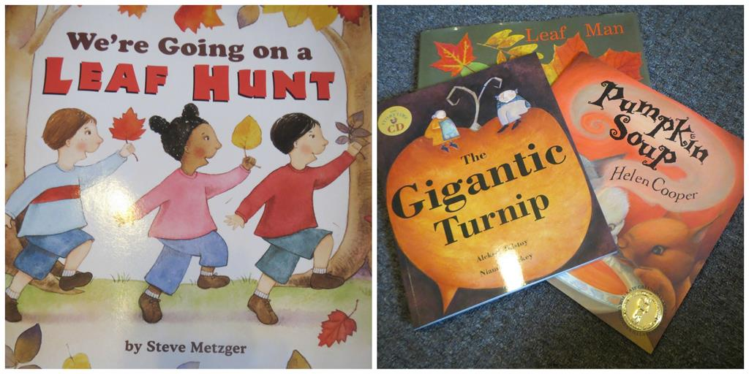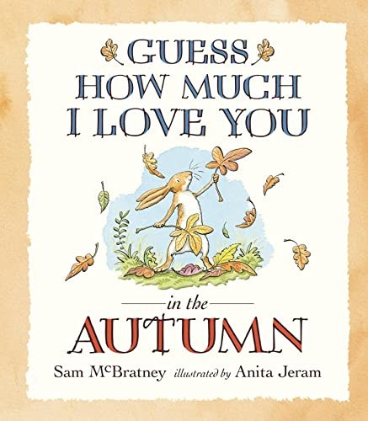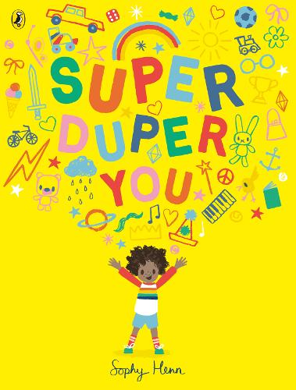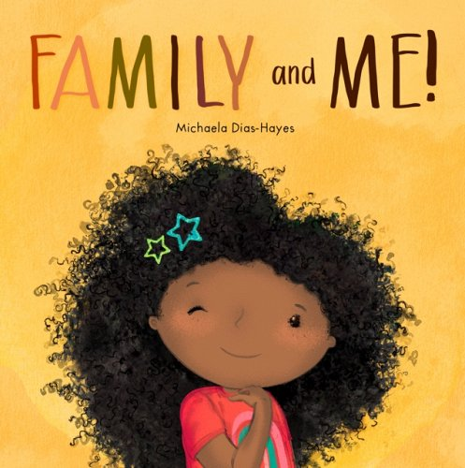
Autumn 2 | 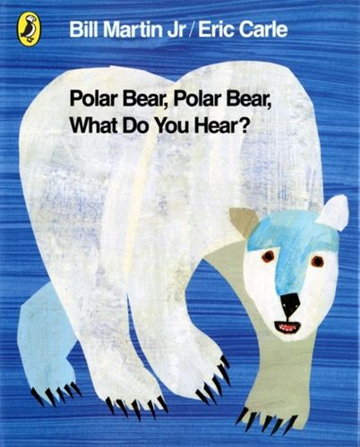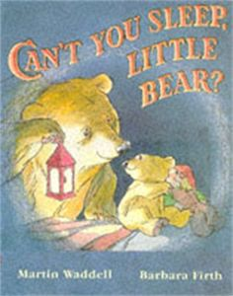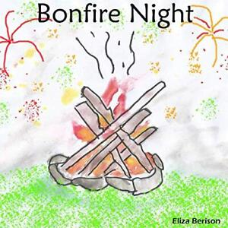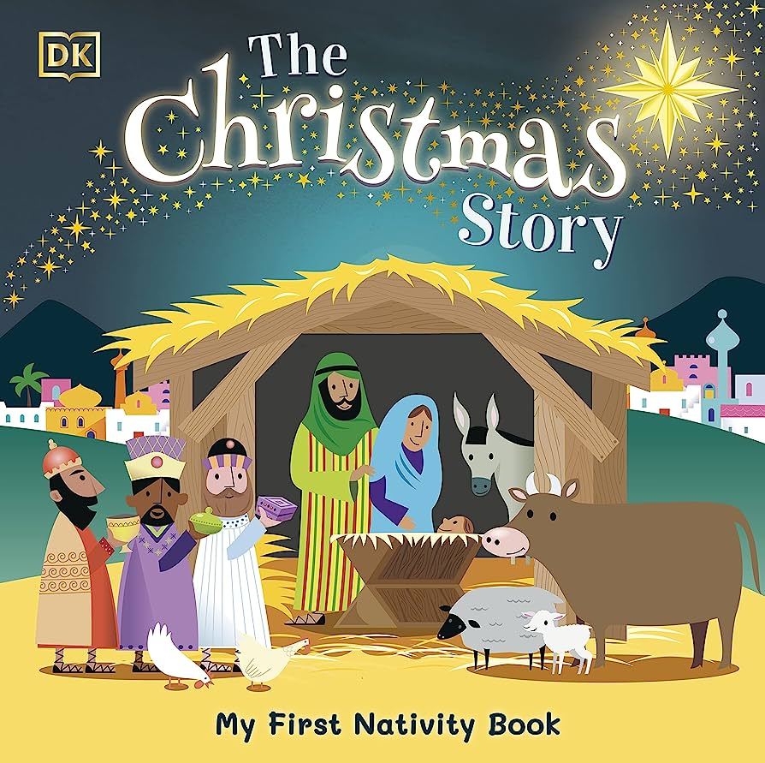
Spring 1 | 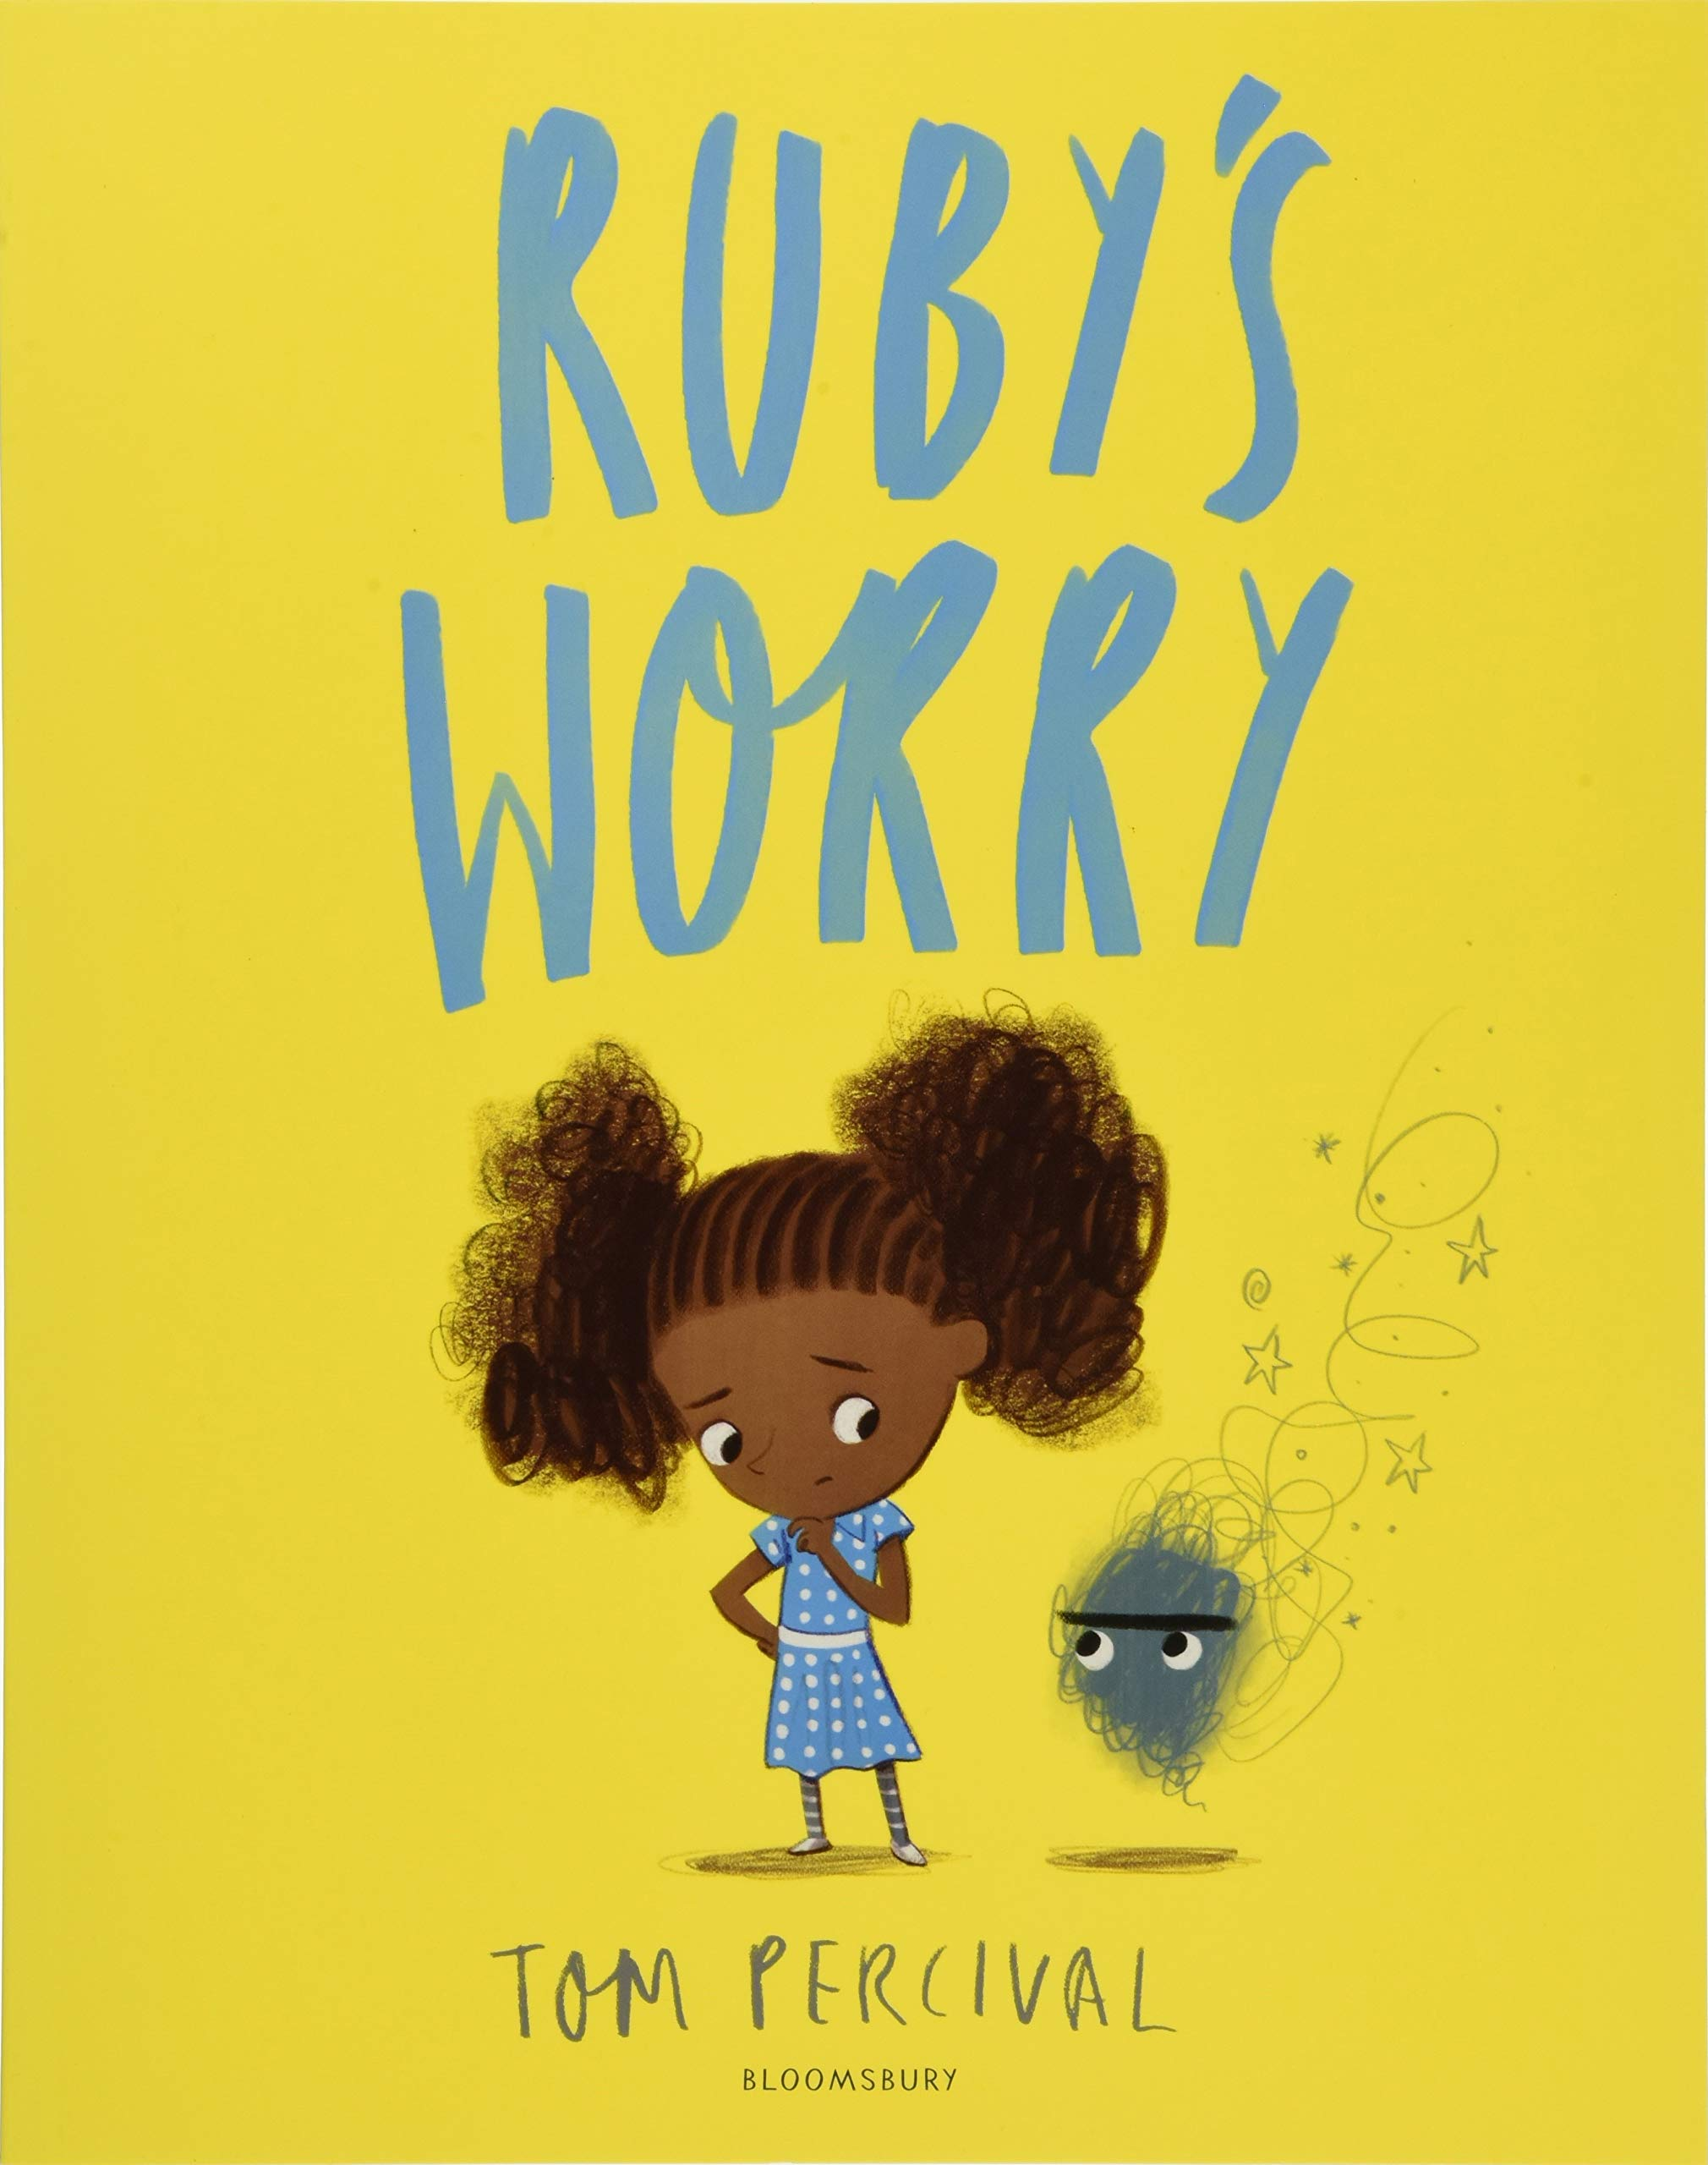  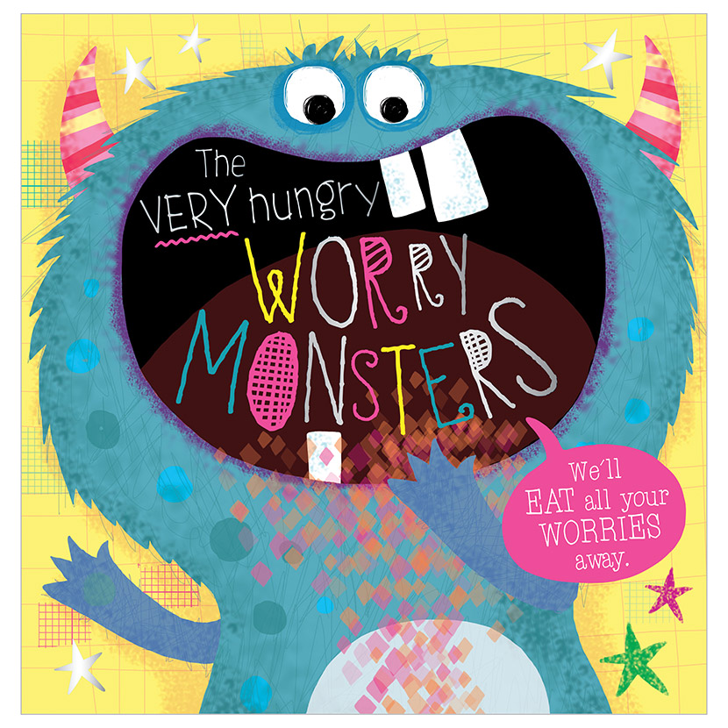  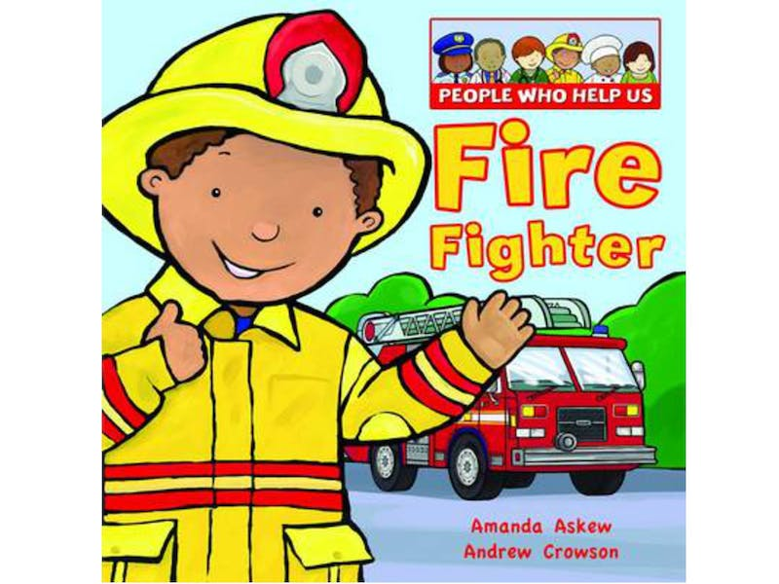  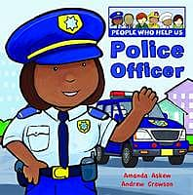
Spring 2  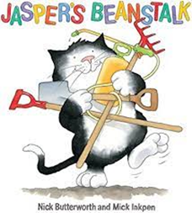 | 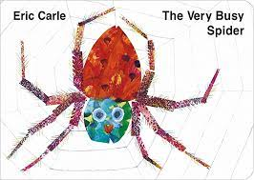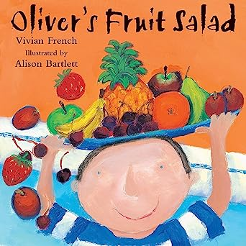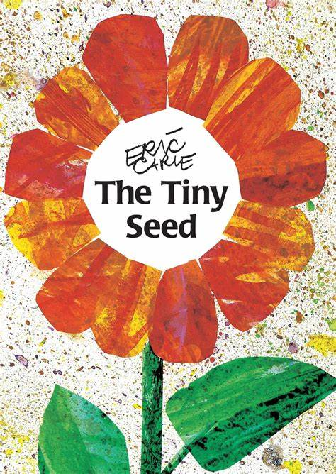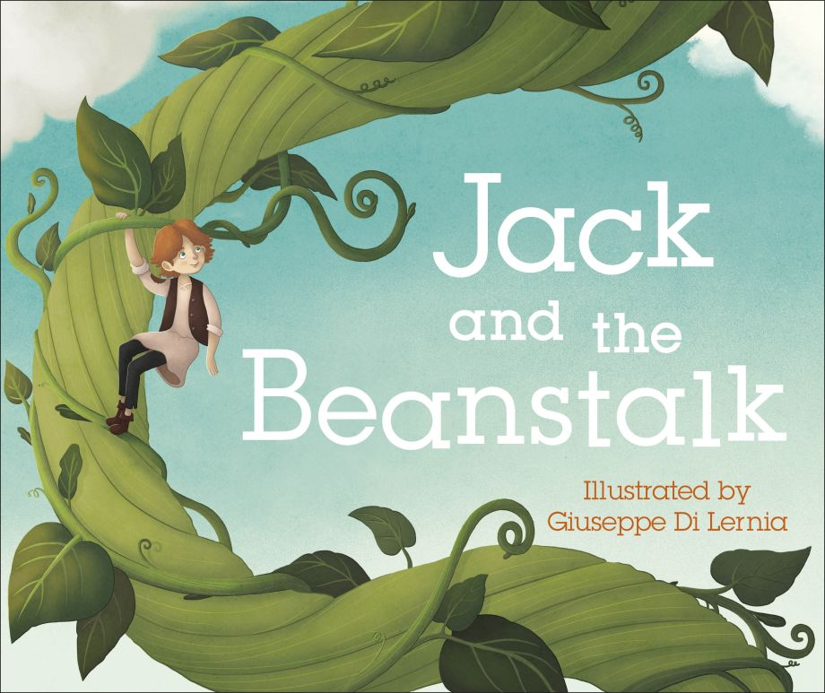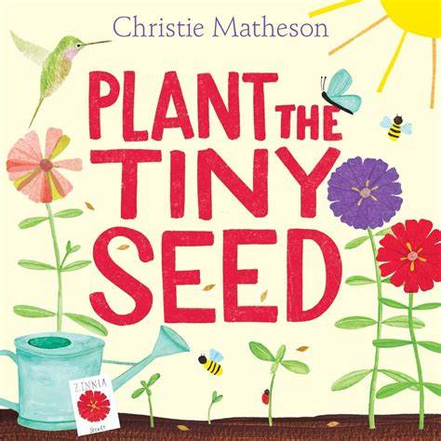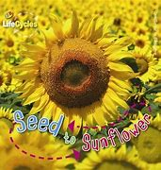
Summer 1 | 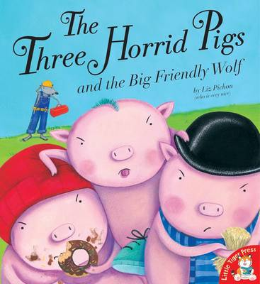 Other traditional and twisted tales
Summer 2  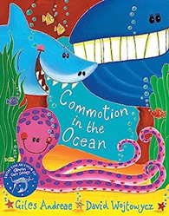 | 

