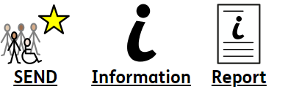


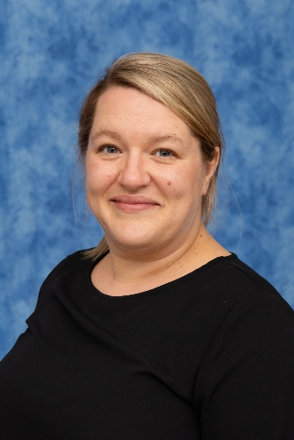

The Special Educational Needs Coordinator at Grange Primary School is:
Mrs Amy Riley



amy.riley@grange.derbyshire.sch.uk
enquiries@grange.derbyshire.sch.uk
0115 9734956

At Grange Primary School we uphold an inclusive admission policy which is built on a whole community approach to special educational needs and/or disabilities where staff, governors, parents and support services work together as a team. We cooperate and work collaboratively, and in co-ordination in all that we do so that we produce the best possible education for all children, including those with SEND.

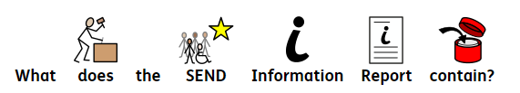
The Special Educational Needs Code of Practice 2014 gives guidance to schools to help identify, assess and provide support for children with special educational needs. It sets out the processes and procedures organisations must or should follow to meet the needs of children.
The Code of Practice 6.79 states that the governing bodies of maintained schools and maintained nursery schools must publish information on their websites about the implementation of the governing body's policy for children with SEND. The information published is to be updated annually and any changes to the information occurring during the year are updated as soon as possible.
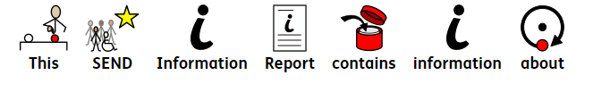
The information required is set out in the Special Educational Needs and Disability Regulations 2014.
➢ The range of SEND that are provided for
➢ Policies for identifying children with SEND and assessing their needs, including the name and contact details of the school SENCO
➢ Arrangements for consulting parents of children with SEND and involving them in their child's education
➢ Arrangements for consulting children with SEND and involving them in their
education whenever possible and appropriate
➢ Arrangements for assessing and reviewing children's progress towards outcomes (including the opportunities to work with parents and children as part of this process)
➢ Arrangements for supporting children in moving between phases of education and in preparing for adulthood (transition)
➢ The school's approach to teaching children with SEND
➢ How adaptations are made to the curriculum and the learning environment of
children with SEND
➢ The expertise and training of staff to support children with SEND, including how specialist expertise will be secured and utilised
➢ Evaluating the effectiveness of the provision made
➢ How children with SEND are able to engage in activities with children in the school who do not have SEND
➢ Support for improving emotional and social development (including extra pastoral support e.g. listening to the views of children with SEND and measures to prevent bullying)
➢ How the school involves other bodies, including health and social care bodies, local authority support services and voluntary sector organisations, in meeting children with SEND and supporting their families
➢Arrangements for handling complaints from parents of children with SEND about the provision made at the school
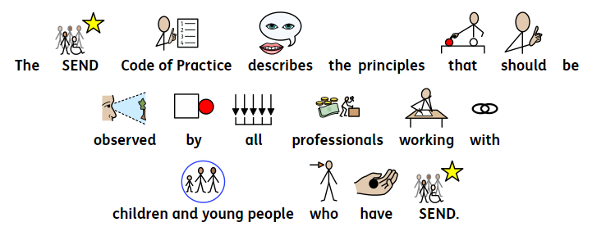
These include:
• taking into account the view of children, young people and their families
• enabling children, young people and their parents to participate in decision making
• collaborating with partners in education, health and social care to provide support
• identifying the needs of children and young people
• ensuring high quality provision to meet the needs of children and young people
• focusing on inclusive practices and removing barriers to learning
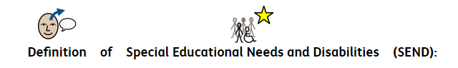
• helping children and young people to prepare for adulthood
The Special Educational Needs and Disability Code of Practice (0-25 years) 2014 states that: 'A pupil or young person has SEND if they have a learning difficulty or disability which calls for special educational provision to be made for him or her.'
A child of compulsory school age has a learning difficulty or disability if he or she:
• Has a significantly greater difficulty in learning than the majority of others of the same age; or
• Has a disability which prevents or hinders him or her from making educational facilities of a kind generally provided for others of the same age in mainstream schools or post-16 institutions.
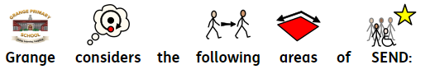

. Communication and interaction which includes Autism Spectrum Disorder (ASD)
• Cognition and learning including severe learning difficulties (SLD / CLD)
• Profound and multiple learning difficulties (PMLD)
• Specific learning difficulties (SpLD)
• Social, mental and emotional health – including attention deficit and hyperactivity disorder (ADHD) and a range of mental health problems and other recognised disorders
• Sensory and/or physical difficulties (SPD)
Mrs Riley, the SENCO at Grange, has completed the National Award in Special Educational Needs Coordination (NASENCO) and has a wealth of experience in supporting children with SEND. She has responsibility for the operation and implementation of the SEND policy and co-ordinates specific provision to support individual pupils with SEND, including those who have EHC plans. Mrs Riley works closely with staff, parents and carers, and other agencies and ensures she has regular contact with the SEND children she supports.
She provides professional guidance to colleagues to secure high quality teaching for children with SEND, and works closely with staff to identify training needs where appropriate.
Mrs Riley oversees the progress and attainment of children with SEND and ensure that effective provision is in place to help children meet their own personal learning goals.
As part of the Senior Leadership Team, Mrs Riley, along with the Headteacher and Governing Body, determine the strategic development of SEND policy and provision at Grange.
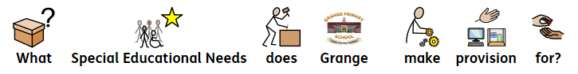
Mrs Riley ensures to offer signposting to social and emotional support via our full time Family and Well Being Lead (Mrs Turner) who we work very closely with on specific cases. We also proactively involve other agencies, including health and social care professionals, local authority support services and voluntary sector organisations in meeting the needs of children with SEND and in supporting their families.
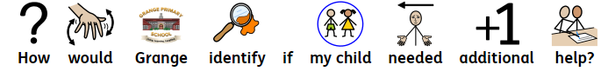
Grange is a primary school, which provides education for 3 to 11 Years (Nursery to Year 6). At Grange we tailor provision to meet the needs of children with a range of different needs, including those who have: moderate and severe learning difficulties, neurodiversity such as; Autism, Attention Deficit and Hyperactivity Disorder (ADHD) and anxiety, Language and Communication difficulties, social, emotional and mental health difficulties and Sensory difficulties. We also provide further provision for children with dyslexic, dyscalculic and dyspraxic tendencies.
At Grange we place great importance on identifying special educational needs early so that we can help children as quickly as possible. We recognise that children make progress at different rates and have different ways in which they learn best. All class teachers differentiate for the needs of their children in every lesson, by looking carefully at: how they plan, the way/style in which they teach the lesson, how they organise the classroom and what resources are needed for each child.
The SEND Code of practice (2014) describes how help for children with special educational needs should be made by adopting a step-by-step or 'graduated approach'.
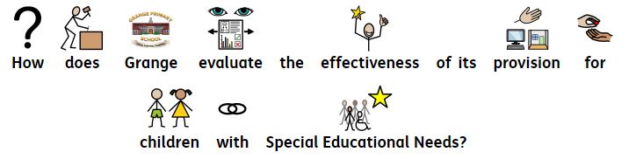
If a child is highlighted as not making expected progress within a particular area of learning they are added to the cohort provision map, which indicates how and when they will receive additional, targeted support for their specific area of difficulty. It is hoped that with additional support, the child would develop in this area and become stronger in it and therefore would not require any ongoing additional support. However, if following a period of targeted support, a child continues to find a particular area(s) of learning a difficulty we would contact parents and arrange for a consultation with the class teacher, parents and the SENCO. We would share information and gather insight from all parties to devise specific targets for the child to work on over the term. We would record the child's specific targets on an Individual Provision Map and if all parties are in agreement, the child would be added to our school SEND register. If despite ongoing, regular intervention, a child had made limited progress, and if they continued to require additional support, we may decide that further specialist support is required from outside agencies. Grange have access to a vast range of resources and development profiles that may be used to assess a child's abilities and we are fortunate to have a number of professionals that we are able to approach to support both the child in their area of need and the school such as: Physiotherapists, Speech and Language Therapists, School Nursing Team, Occupational Therapists and Specialist Teachers in a variety of areas. The school finds it extremely beneficial to receive support from outside agencies
All children's progress is rigorously tracked by members of the school's Senior Leadership Team. The SENCO closely tracks the progress of all SEND children and those children who may not be making expected progress. Grange employs a full time SENCO who is available to support and liaise with staff regularly to ensure that school is providing effective provision for these children. Both class teachers and the SENCO track the effectiveness of a number of interventions, such as; Number Stacks, Physical Literacy, ECaT, Talk Boost, Sound Discovery, Precision Teaching, Speech Link, RWI Phonics, Attention Autism, Nessy: Reading and Dyslexia, Nessy: Touch Typing and Lego Therapy. In addition, some children are also identified as needing specific social, emotional and mental health intervention for which packages of support are devised though individual Boxall profiles. Monitoring the effectiveness of interventions allows us to ensure that specific programmes of support are having a positive impact on children's development and progress. School Governors are kept informed of the progress of all children and termly SEND impact reports are discussed at committee meetings.
Children who receive additional support are continually assessed and their provision is continuously reviewed. Individual Provision Maps and accompanying SMART targets are reviewed every term by both your child’s Class Teacher(S) and the SENCO. Data is collected and analysed to ensure the impact of interventions and provision and to identify the next steps in individual children's learning and development. As well as the formal review on a termly basis, children's Individual Provision Maps can be adjusted between these times as required.
Individual Provision Maps include interventions (where appropriate) at Waves 1-3 and any advice and strategies that have been sought from outside agencies is included. These are shared with parents and carers each term and parents and carers are invited to review their child's progress and comment on the next steps for their child.
If a child has an Education and Health Care Plan (EHCP) these children also have an Individual Wave Map which is reviewed in the same manner. However, these children also have a legal document outlining provisions for the Key Stage they are in which are revied during Annual Reviews. All outside agencies involved with the child named in the EHCP will be invited to attend an Annual Review to review progress, assess the current need of the child and contribute to making amendments and setting new targets if necessary.
Identification and assessment of children with SEND will include:
• End of Key Stage attainments (end of Year 2 and 6)
. Pre Key-Stage Assessments
. Engagement Model
. Celebratory Checkpoints
. Formative Footprints
• Assessment for Learning
• Standardised tests/ baseline entry assessments
• Teacher observation
• Information and advice from other agencies
• Views of the child
• Views of parents
• Diagnostic tests as required
• Observational checklists
• observing and recording responses in different environments
• identifying strengths and weaknesses
• identifying learning rates and learning styles
This assessment information highlights children who are making less than expected progress given their age and individual circumstances. This can be characterised by progress which:
➢ is significantly slower than that of their peers starting from the same baseline
➢ fails to match or better the child's previous rate of progress
➢ fails to close the attainment gap between the child and their peers
➢ widens the attainment gap
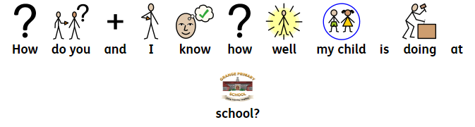
We aim to meet with parents at regular points throughout the year. Your child's needs will be a factor in the level of contact that we will require from you. As a school we hold two parent consultation evenings each year. We send out at the beginning of the year expectations for each year group on a newsletter and you will receive an annual report at the end of the school year. If your child has an Individual Provision Map, we will aim to meet you on three occasions throughout the year to discuss the progress they have made and set their new targets.
If your child has an EHCP, the plan will be reviewed at least annually.
As a school we hold an 'open door policy', therefore parents are invited to contact the school with any problems or queries, as and when is necessary.
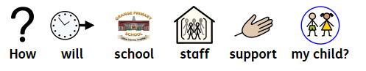

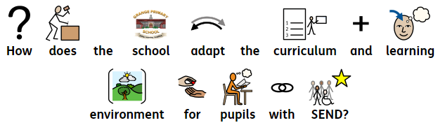
The support your child receives will be dependent upon your child's needs. For example, if your child has Early Years Inclusion Funding, Inclusion Panel Funding or an EHC Plan, school will receive additional top-up funding to support your child’s individual needs. All children who are on the SEND register will have an individual provision map (IPM) and interventions and strategies will be listed that are specific to their needs and development. Children may receive 1:1 support, small group targeted support - in and/or out of the class, by either a teacher or a teaching assistant through intervention and booster groups, which may take place over one or two terms. Class teachers are responsible for planning and delivering the appropriate support to meet the needs of the children in their class. Therefore, where possible, children will be fully integrated into classroom life, whilst receiving an appropriately challenging curriculum.
As all children are individuals the curriculum will be adapted to suit their individual needs. This may be achieved by providing children with resources to support learning opportunities or bespoke learning challenges that are more suited to their needs than what is ordinarily available to children within their age range.
Prior thought is given to where children are positioned within the classrooms for a range of reasons, and this can change as new needs arise.
Fortunately, the school has a number of additional rooms, which are separate to the classrooms, that enable children to participate in some activities in a quieter or less visually stimulating area. Some children will carry out their targeted IPM work in these rooms, although this is not necessary for all children and most children will be supported within their classrooms. These intervention rooms are also used for regular interventions such as Phonics and Speech and Language as well as for booster groups which often take place during English and Maths lessons in small groups to allow for a greater level of support when needed.
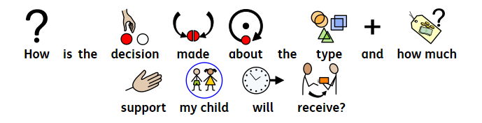
If your child has an EHC Plan or Inclusion Funding their needs will have been identified through this by the Local Authority. This will indicate how much support your child needs and what this support looks like.
As a school we will provide additional support at times, when we feel necessary. If your child is receiving support through class provision maps or an IPM their level of support will be very specific to their needs. Where possible the school will discuss you child’s IPM with both you and your child and you will be involved in deciding the right support for your child. Should the school be unable to meet the needs of your child through their normally available resources, either yourself or the school can contact the Local Authority for an assessment of your child’s needs.
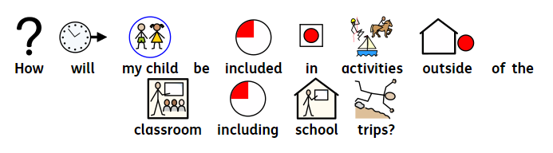
All year groups have access to school trips and visitors throughout the year. Where possible and where adaptations/alternatives can be made, the school aims to fully include all children. It may be that children require additional adult support or resources – such as a named 1:1 supporting TA, pushchairs /wheelchairs for visits out of school. Where additional risks are identified, a discussion will be had with parents/carers to ensure the safety of your child prior to any trip.
When children reach KS2, there is an opportunity for children to attend residential trips. Any adaptations required for these trips would also be carried out prior to a trip commencing and through conversations can be had at the time with both the class teacher involved and the SENCO. As all trips are unique, any necessary arrangements for lunch, toileting and breaks would be discussed with you as necessary.
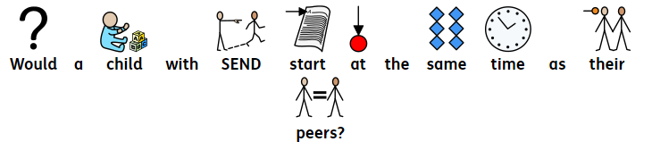
We plan for all children to begin their journey at Grange with their peers. If a child enters school with an EHC Plan, we would plan a range of transitional activities into school. For example, we may arrange additional visits and sessions in school, short story sessions, lunch sessions, and hold any professional meetings that would be beneficial prior to your child starting school. We make picture passports for all children each year, which you can share with your child prior to them starting school. These include; photographs of their class teacher(s) and TA(s), photographs of your child’s new classroom and lots of other details (with visuals and additional photographs of routines)
If a child joins us from another school or setting the allocated SENCo would liaise with the previous SENCo to ensure we have as much information as possible about the child. On occasions, we have provided children with a reduced timetable on entry, this is planned for individual circumstances where appropriate and is usually put in place to support medical and or mental health needs.
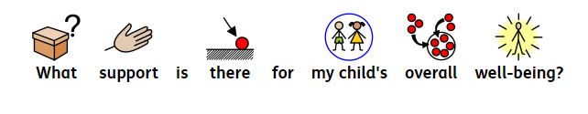
We have a robust safeguarding policy in place. children’s health and well-being are paramount; therefore, we work closely with medical practitioners. If your child has a medical / health need we will write a care plan specifically for them. If children require medication during the school day, a consent form will have to be completed prior to the administration and all medicines will kept securely in the main office (inhalers are kept in children’s individual classrooms). If children require support with personal care this is conducted discreetly and aims to foster independence whenever possible. We also provide all staff (including lunch time staff) with any information that may be needed to specifically support your child. We work closely with Derbyshire Multi Agency Teams, which enables us to recommend or provide additional support to children and families where appropriate. Within school we have staff specifically trained in emotional support and wellbeing and children are able to access this support as and when needed. All classrooms have a regulation station which they can access independently and there are several breakout sensory rooms that can be used within school for children who need this provision. We also have staff members trained in the delivery of Positive Play and this intervention is delivered 1:1 for children who require this level of support.
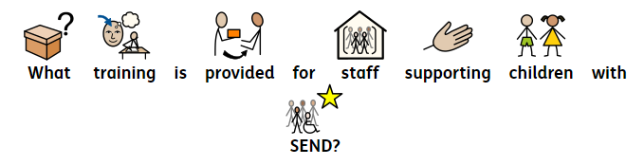
Our staff have a range of knowledge and expertise of strategies and interventions that are relevant to supporting children with SEND. These include, but are not limited to; speech and language difficulties, relational behaviour strategies, Dyslexia and Dyspraxia support, Autism Advocacy and awareness, communication and interaction difficulties, physical difficulties and physical therapy, SEMH difficulties and a range of congenital birth conditions.
All staff have received basic relational behaviour management training, whilst some have further expertise in this area. Our Inclusion Advisory Support Teacher works closely with class teams to provide targeted support that is suitable for specific children as well as providing support at whole school level on wider priorities. We are committed to developing staff’s knowledge and keeping their skills up to date, therefore regular training takes place throughout the year.

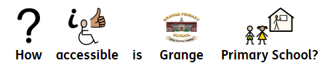

Our school is fully accessible. Although we do not have access to the Year 5 and 6 classrooms via a lift, should this become a need in the future we would relocate these classrooms to an accessible part of the school.
We have dedicated toileting facilities and ramps positioned around school and we work closely with the Physical Impairment Team to make additional adaptations and provide additional resources for children who require these. We also work closely with the Hearing Impairment Team and always evaluate how we can make our classrooms as accessible as possible for children with hearing impairments.
We use Widgit symbols to support accessibility by providing visual representations of language, helping children with communication difficulties understand and express themselves more clearly. Using visual representations and printed materials supports children to read and navigate their surroundings, promoting independence and inclusion.

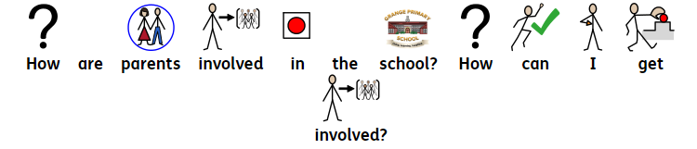
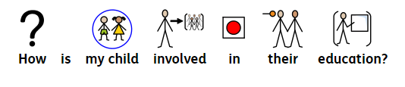
We hope to meet lots of new parents when you are deciding on your choice of primary school. We hold a number of parents’ open evening for new parents in June / July, as well as providing visits for the children before they start Reception in the September. We also hold a new parents meetings in June or July for the children who are starting at the Nursery. We encourage all parents to come and visit where they will be shown around with chance to speak the SENCO and Family and Well-Being Lead. The school PTA (FROGS~ Friends of Grange School) organise many social events and fundraising activities throughout the year, such as Christmas and Summer Fayres, Discos and coffee mornings. Please see the school office or our school website for more information. their child.
When it is appropriate, your child will be fully involved in reviewing and setting their new targets. Children are involved in the reviewing process of IPM’s and EHC Plan reviews. In school we also encourage children to take control of their day-to-day learning. This is achieved by giving them choices about how to tackle learning challenges, the style in which they complete a learning challenge or the level of the challenge that they are completing.
We also have a school council, which is made up of representatives from every class, from years two – six. These children meet with the designated teacher every two weeks. They have been responsible for developing play times as well as other important issues around the school.
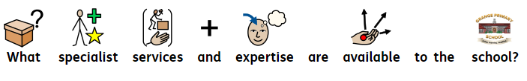
We work closely with the following to support the needs of children in our school:
o Inclusion Support Advisory Service
o Speech and Language Therapists
o Physiotherapists
o Occupational Therapists
o Physical Impairment Team
o Educational Psychologist
o School Nursing Team
o Social Workers
o CAMHS
o ADHD Nursing Team
o Hearing Impairment Team
o Visual Impairment Team
o SEND Officers for Erewash Area and Derbyshire County Council
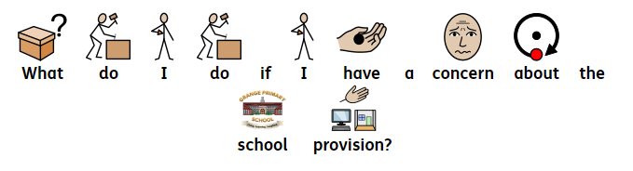
If you have any enquires regarding support for your child and SEND, please contact Mrs Amy Riley - our school SENCO. If you have a concern regarding the school provision, please contact Mrs Alexandra Barto-Smith our Deputy Head teacher. For specific behaviour and curriculum issues please contact Mrs Zoe Buxton our Head teacher. In the unlikely event that your concern is not resolved then please contact our Chair of Governors – Mr Steeve Hessey. All contact details can be found on the school website
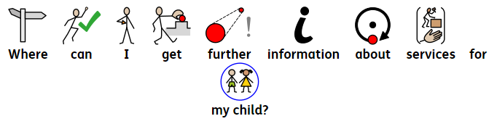
The information in this report forms a part of Derbyshire County Council’s local offer. This can be accessed at: http://www.derbyshire.gov.uk/education/schools/special_educational_needs/support_aspi ration/local_offer/default.asp

Written by: Mrs Amy Riley
Approved by: Mrs Zoe Buxton (Headteacher)
Implemented: September 2023

Review Date: | Reviewed by:
September 2024 | Amy Riley, Zoe Buxton and FGB
September 2025 | Amy Riley, Zoe Buxton and FGB
September 2026

