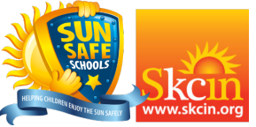
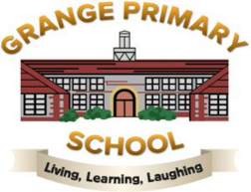
28th April 2025

Dear Parents / Carers,
We are pleased to inform you that Grange Primary School are taking part in the Sun Safe Schools national accreditation programme - the content of which forms part of our duty of care to ensure the health and wellbeing of your child(ren) during school hours.
Whilst we recognise that some sun is good for us, sun protection is an important safeguarding issue. Children spend almost half their childhood at school, with a great deal of time spent outdoors. During the warmer months of the year children are exposed to Ultraviolet Radiation (UVR) from the sun, the majority of which is when penetration is strongest (between 11am and 3pm). Without adequate protection, a child's delicate skin can easily burn, this can cause cumulative and irreparable damage that can significantly increase their risk of developing skin cancer in later life.
Whilst skin cancer remains the UK's most common and fastest rising cancer, the good news is that it is almost entirely preventable (around 90% of cases!) and with parental support, simple steps can be undertaken to ensure that your child is protected, can enjoy the sun safely and learn to develop healthy lifestyle choices.
Please take the time to read through our Sun Protection Policy which is available to view online via the following link: https://www.sunsafeschools.co.uk/school/15262
This policy demonstrates our commitment to providing a Sun Safe environment, protective measures and education.
Parental support will play a vital role in our efforts to implement effective control measures, particularly with the provision of suitable sunscreen and sun hats.
In-line with our Sun Protection Policy we ask that parents ensure their child(ren) are equipped with a suitable sun hat and sunscreen that are clearly labelled and brought to, or kept at school from April through to the end of September for use/application when required. Sun hats should be either broad-brimmed (bucket style) or legionnaire to shade the face, neck, ears and cheeks. We recommend sunscreen with a Sun Protection Factor (SPF) of 30 or above with at least 4 star UVA protection. A practical approach towards the application of sunscreen is necessary. We therefore encourage the self-administration of sunscreen by pupils. Most children, apart from the very youngest or those with special needs, will be able to do so under supervision. Where assistance may be necessary, parents should request advice and follow guidance from the school.
As we work toward our Sun Safe Schools Accreditation, all children will learn about safe and unsafe exposure to the sun and how to reduce the risk of sun damage, including skin cancer. We can assure you your child(ren) will have lots of fun learning about this subject through the Sun Safe Schools programme that focuses on developing their knowledge of UVR and how to enjoy the sun safely.
Guidance and practical advice about the risks associated with UVR and the prevention and early detection of skin cancer is available to download via the link provided to our Sun Protection Policy above.
Thank you for your valued support.
Grange Primary School

