OVERVIEW OF AUTUMN 1 - Year 3
Mrs Winslow & Mrs Ruddle / Mrs Trembirth &
Mrs Fletcher

Mrs Fletcher

Year
Yr
YEAR

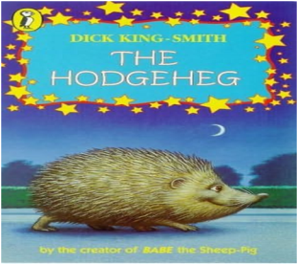
Computing
During this term the children will be exploring computing systems and networks
They will also be using the internet for research and using iPads and the laptops to assist them in their learning.

Science – Our focus for this half term is plants. We will look at the different parts of the plant and their roles, as well as exploring the life cycle of a plant, including pollination and seed dispersal.

REMINDERS
- Healthy nut free snacks at morning break please – (the children do not get fruit in Key Stage 2).
- Please ensure that school uniform is labelled.
- Homework will be given out on Thursdays and returned on Wednesdays.
- Spellings are tested on a Wednesday.
- Your child will be given a Times Tables Rockstars log on to support their home learning with times tables.
- We will be assessing the children in the KS2 accelerated reading scheme before books come home.

Geography
We will be using maps and atlases to locate the world’s countries and describe the features studied.
Art/Design Technology
Pupils will learn about the artist Georgia O’Keefe, how to use sketching pencils and create a wash using paint.

Literacy
This term we will be reading Mr Stink as a class.
In Shared Reading, the children will focus on different weekly texts, generating and answer questions about the text as well as making predictions.
In writing, we will be learning to write character descriptions and fact files.
We will be learning weekly spellings. The spellings are taken from a National Scheme of work through Spelling Shed and are linked to Year 3 learning.

Mathematics
We will start the year off looking at place value and ordering of numbers. We will then move on to looking at addition and subtraction.
The children will continue to revise and improve mental maths skills, particularly their recall and speed of times tables. They will also continue to develop their understanding of mathematical vocabulary.

PE
Mr Oliver will take the children for their PE lessons on a Wednesday morning. They will be developing skills linked to invasion games

What makes plants grow and flourish?
RE/PSHE
In RE we will learn about Christianity and how Christians live their lives.
During our PSHE sessions we will look at why we need rules, the qualities that make a good friend and difference and diversity within communities.

