**English**

Linked to our topic, this half-term, we will be reading Cosmic by Frank Cotteral-Boyce.

In Shared Reading, the children will focus on different weekly texts, generating and answering questions about the text as well as making predictions.

Your child is welcome to change their reading book every day. We will be checking their reading diaries once a week. Children will receive one bronze sticker for each day they read, please ensure all reading at home is recorded.

In writing, our work will focus on the theme of traditional tales, with our hot task focussing on creating our very own! We will then move on to writing science fiction narratives using all of the SPaG features we have been working on throughout the term.

Weekly spellings are taken from a National Scheme of work and are linked to Year 5 learning. Please log onto EdShed to practice them through the assignments tab.

**Spring 2 Newsletter**

***Welcome back all!***

***We are really looking forward to an exciting half term of learning!***

**Year**

**Yr**

**YEAR**

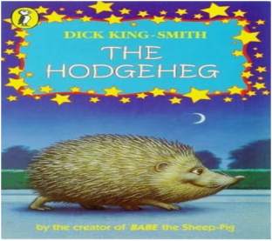

***Notes***

Please send in a *healthy* snack at morning break.

Homework and spellings will be given out on a **Thursday**, to be handed in by **Wednesday**. The spelling test is every Thursday.

All the children will be taking part in a clarinet lesson every Wednesday afternoon. If you have signed the consent form, your child will bring their clarinet home to practice (lucky you!). Please ensure these are brought back into school by ***Tuesday*.**

Please ensure that school jumpers and cardigans are labelled. A biro will do. Please ensure all uniform worn is correct.

Friday is Feel Good Friday in Year 5. As part of this, the children are invited to bring slippers to school to wear during the day.

**Science**

The children will be developing their scientific and investigative skills through a range of learning opportunities. We will be looking at the topic Earth and Space; looking at the planets, how they move and their locations within space.

**RE/PSHE**

* In our RE lessons this half term we are discussing Christianity, the Bible and the Easter story.
* Our PSHE sessions are focussing on ways to be healthy. We will be discussing the concept of a balanced, healthy lifestyle both physically and mentally.

**Art**

Our focus this half term will be on Space related art. We will be looking at Peter Thorpe and creating rockets in his style using pastels.

**Topic**

We are starting our exciting topic about Anglo Saxons

The children will be stepping into a time machine to explore the historical impact they had on Britain and how that has influenced us today in the modern world. We will investigate what a typical Anglo-Saxon village was like and how they lived.

**PE**

Mr Oliver will take the children for their PE lessons every **Tuesday** morning. Please come in wearing correct PE kit.

**Mathematics**

During this term, the children will focus on decimals and percentages

Alongside this, we will also be developing the children’s recall of times table facts through fluency and TTRS practise. Your child’s login details are in their reading diary if they would like to practice at home.

**Computing**

This term the children will be learning how to create flat-file databases and linking their learning to maths.