OVERVIEW OF AUTUMN 1 - Year 1
Mrs Hancock and Miss Darnell

Mrs Fletcher

Year
Yr
YEAR

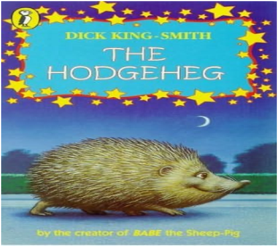
Literacy
This term we will be reading books related to ‘What does it mean to be me?’ including ‘Incredible You’ by Rhys Brisenden, ‘My Hair’ by Hannah Lee, ‘Giraffes Can’t Dance’ by Giles Andreae and many more.
In Phonics (Read, Write, Inc), the children will be grouped based on their assessment, and will be following either set 1, set 2 or set 3 sounds.
In writing, we will be focusing on handwriting and sentence structure.

PE
Mr Oliver will take the children for their PE lessons on a Tuesday afternoon. They will be developing Invasion Game skills in their lessons.

Mathematics
We will start the year off looking at place value to 10 and ordering of numbers. We will then move on to looking at addition and subtraction.
The children will continue to develop their understanding of mathematical vocabulary.

RE/PSHE
In RE we will learn about Christianity.
During our PSHE sessions we will look at why we need rules, the qualities that make a good friend and difference and diversity within communities.
Geography
We will be learning about the United Kingdom, with a focus on England, Scotland, Wales, and Northern Ireland, as well as their flags and national flowers.
Art/Design Technology

The children will learn about the artist Jackson Pollock by using the ‘drip technique’.

What is the United Kingdom?
Computing
During this term the children will be learning about a keyboard and how to use computers responsibly.

Science –
Our focus for this half term is Humans. We will look at the different body parts of the human body and learning about our senses.

REMINDERS
- Healthy nut free snacks at morning break please – (the children do also get fruit)
- PE is on a Tuesday.
- Please ensure that school uniform is labelled.
- Homework will be given out on Thursdays and returned on the following Thursday.
- Ensure you can log into WEDUC for communication purposes.

Dates
Friday 25th September – Workshops start.
Tuesday 20th October – Police Officer visit.
Tuesday 20th and Wednesday 21st October – Parents Evening.

