Yearly Curriculum Overview
Year 1 – 2025/2026

 | Autumn 1  (7 weeks) | Autumn 2  (7 weeks) | Spring 1  (7 weeks) | Spring 2  (5 weeks) | Summer 1  (6 weeks) | Summer 2  (8 weeks)
Driver | PSHE/Geography  I wonder…. What does it mean to be me?  Why should I be proud of being me? Am I the same as my friends? What do I look like? Where do I live and who is my family? What are my likes and dislikes? Do we all speak the same language? Let’s celebrate us! | History  I wonder…. How have toys changed overtime?  What do you know about toys? What is your favourite toy? Are toys all the same? What are toys made from? Can toys move? What toys are fashionable? If you could have a toy of the future for Christmas, what would it be? | Geography  I wonder…. What’s exciting about where we live?  Where in the world would you live?  What is in Long Eaton? What does it look like from above? What is our school like? How do we make a map of our school? | History  I wonder… How would you travel?  How has transport changed overtime? How does transport fit together? What was special about the titanic? Who were the wright brothers? Who was Neil Armstrong? | Geography  I wonder…  How does your garden grow?  What animals live in our garden? Why do bees love flowers? Do worms help the garden grow? Why do snails carry their homes with them?  How do plants know which way to grow? | History  I wonder… Was Robin Hood a villain or a hero?  Where can we find out about Robin Hood? Who was Robin Hood? Where did Robin Hood live? Why is Robin Hood famous? What impact has Robin Hood had on our local area?
WOW | Diwali  Comparing jobs – visitors  Sharing photos from childhood | Favourite toys  Christmas Nativity  Christingles  Christmas craft day with parents | New year resolutions  Photographs of long Eaton  Library visit  Walk around Long Eaton/School  Making a map/poster | Easter Bonnet Parade  Animal magic visit  Vehicle experience – West Lorry | Parent Gardening Afternoon | Library walk – Robin Hood  Robin hood day
TOPICS | Science (Animals including humans)  PSHE (Difference and Diversity) Geography (How many countries are in the UK?)  RE: Christianity  Art (Jackson Pollock) | Science (Materials)  PSHE (Bullying Matters)  History (Toys)  RE: Christianity  D&T (Mechanisms) | Science (Seasonal changes)  Geography (Where do we live? – Long Eaton, Places to go)  PSHE (Being Responsible)  RE: Islam and Muslims  D&T (Construction) | Science (Animals)  PSHE (Being Healthy)  RE: Judaism  Art (Printing)  History (Transport and notable people and events from the past) | Science (Plants and Animals)  PSHE (Relationships)  Geography (Hot and Cold Places)  Art (Dream Catchers)  RE: Islam | History (Significant people)  PSHE (Exploring emotions)  Geography (Nottingham)  D&T (Textiles)  Art (Henri Matisse)  RE: Islam
English | - The World Needs Who You Were Meant to Be’ by Joanna Gaines. (1 week)  Genre- Fiction  Writing Focus- assessment  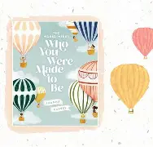  End outcome: simple sentences  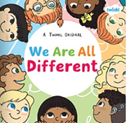  - We are all different - Twinkl- (1 week)  Genre- Fiction  Writing Focus- capital letters  End outcome: simple sentences  I like bees but I Don’t like Honey by Sam Bishop– (1 week)  Genre- Fiction  Writing Focus- connectives  End outcome: simple sentences  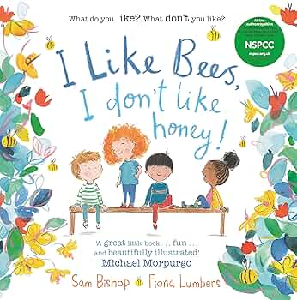  Drawing Club:  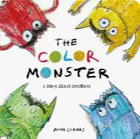  - The colour Monster by Anna Llenas- (1 week)  Genre- Fiction  Writing Focus- finger spaces  End outcome: simple sentences  - How to hide a Lion from Grandma by Helen Stephens – (1 week)  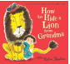  Genre- Fiction  Writing Focus- re-reading  End outcome: simple sentences  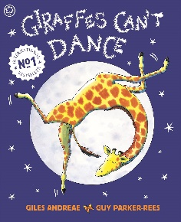  - Giraffes can’t Dance by Giles  Andreae (1 week)  Genre- Fiction  - Clothesline clues for jobs people do  by Deborah Hembrook and Kathryn Heling ( 1 week)  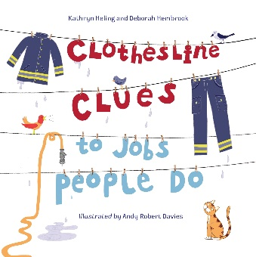  Genre- Fiction  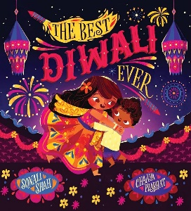  - .The Best Diwali Ever by Sonali Shah  (1 week) | - Farmer duck (2 weeks)  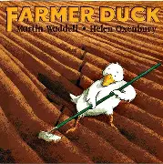  Genre- Fiction  Writing focus:  Oracy, role play, adjectives, simple sentences.  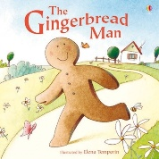  - The Gingerbread man (2 weeks)  Genre - Fiction  Writing focus:  Instructions, Sequencing  Adjectives, simple sentences.  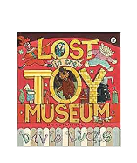  - Lost in a toy Museum (2 weeks)  Genre- Fiction  Writing focus – Comprehension,  simple sentences, adjectives,  Last week – Christmas focus and finish off any writing from previous story. | - Owl who is afraid of the dark (2 weeks)  Genre – Fiction  Oracy, adjectives, simple sentences, owls  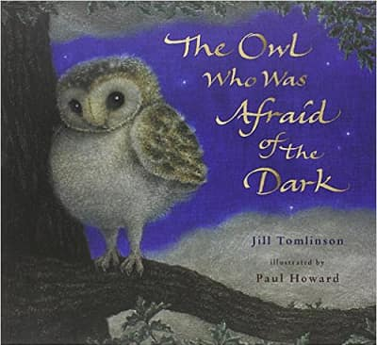  - Little red riding hood (1 week)  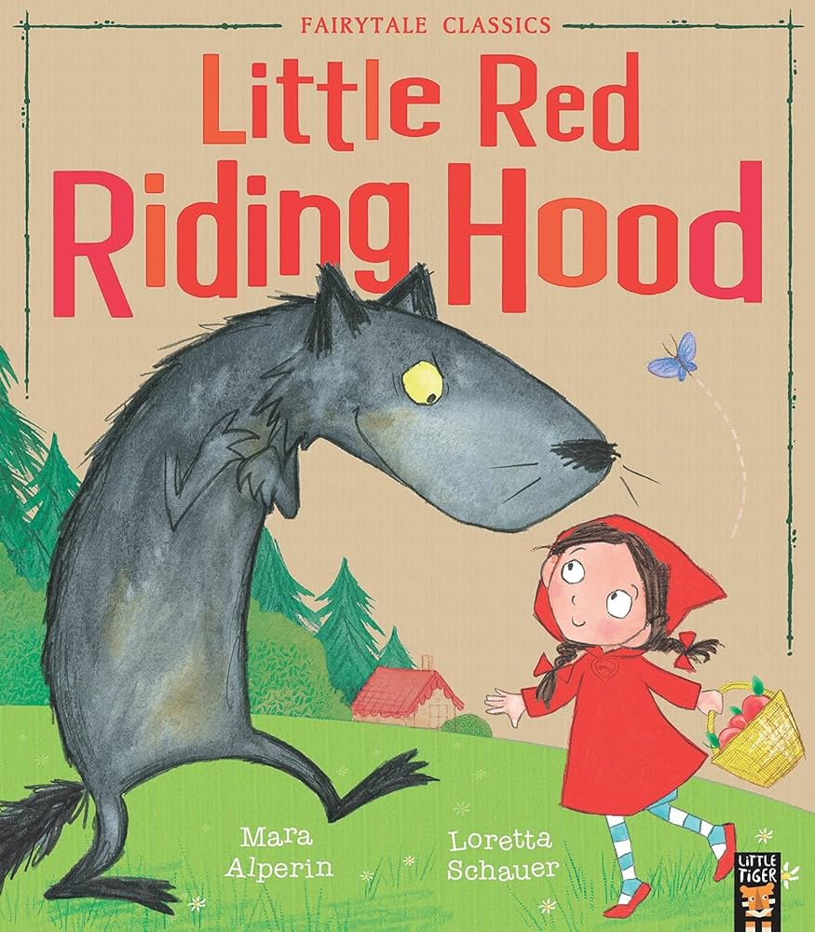  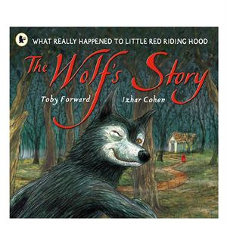  - The Wolfs story (2 weeks)  - Claude in the city (2 weeks)  Story sequencing  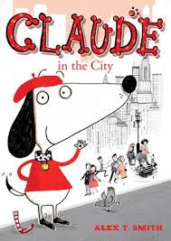 | Key texts around the topic of Transport  Potential texts (TBC)  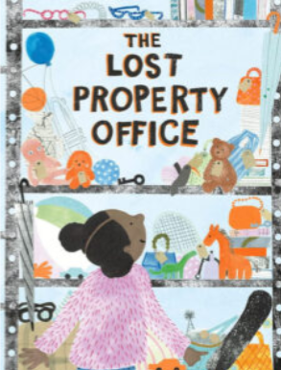  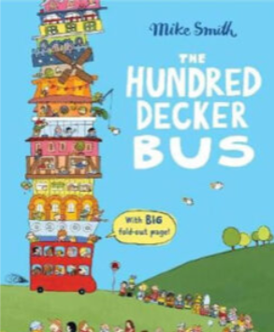  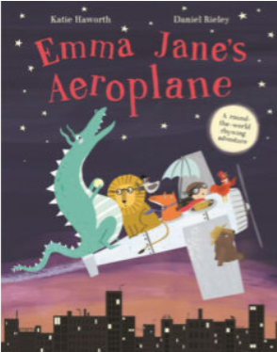 | Animal Boogie (2 weeks)  Genre – fiction/fantasy  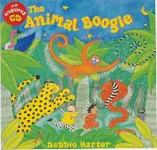  Writing Focus- similes and adjectives in poetry  End Outcome – Poem  - Chimpanzees of happy town (1 weeks)  Genre – fiction  Writing Focus- adjective lists  End Outcome – descriptions  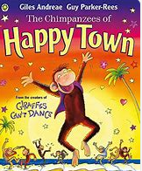 | - Robin Hood (2 weeks)  Genre – fiction and film  Writing Focus- letter features  End Outcome – comparisons  Robin Hood (2 weeks)  - Genre – fiction and film  Writing Focus- Wanted poster  End Outcome – factfile  - When I’m big (2 weeks)  Genre – fiction  Writing Focus- story / narrative features, contractions.  End Outcome – simple sentences with contractions and opposites.  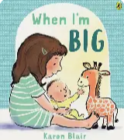  “I will stay up late and I won’t go to bed at 7pm.”  - Imagine me a pirate (2 weeks)  Genre – action  Writing focus – Paragraph  End outcome – Imaginative writing.
Mathematics | White Rose:  - Place Value and Number (within 10) – (5 weeks)  - Addition and Subtraction (within 10) – (2 weeks) | White Rose:  Addition and Subtraction (within10) (2 weeks)  Geometry: Shape (1 week)  Number: Place Value (within 20) (3 weeks)  Assessment and consolidation (1 week) | White Rose:  Number: Addition and Subtraction (within 20) (3 weeks)  Number: Place Value (within 50) (2 weeks)  Measurement: Length and Height (1 week) | White Rose:  Measurement: Length and Height (1 week)  Measurement: Weight and Volume (2 weeks)  Assessment and consolidation (1 week) | White Rose:  Number: Multiplication and Division (3 weeks)  Number: Fractions (2 weeks)  Geometry: Position and Direction (1 week) | White Rose:  Number: Place Value (Within 100) (2 weeks)  Measurement: Money (2 weeks)  Measurement: (time) (2 weeks)  Assessment and consolidation (1 week)
Science | Animals Including Humans  - Identify, name, draw and label the basic parts of the human body.  - Say which part of the body is associated with each sense.  - Explore the 5 senses – what do you like? What do you dislike?  - Animal diets: carnivore, herbivore, omnivore. Vegetarian  - Human and animal body parts: e.g. body, head, neck, arms, elbows, legs, knees, face, ears, eyes, nose, hair, mouth, teeth, hands, feet, tail, wings, feathers, fur, beak, fins, gills.  - Human senses: sight, hearing, touch, smell, taste.  - Exploring senses: loud, quiet, soft, rough.  Other: human, animal, pet.  Science and inventors – lesson 8 | Everyday Materials  - Identify and name everyday materials.  - Describe simple properties of everyday materials.  - Sort objects by their material and material properties  - Suggest common uses for materials  - Describe and compare the properties of everyday materials  - Distinguish between an object and the material it is made from. • choose an appropriate material for a specific purpose  - Perform simple tests.  - Use their observations to answer simple questions.  - Scientists and Inventors  - Lesson 1  - observe and describe 4 properties of plastic;  • take part in an investigation to find out the best materials to keep us warm. ...most children will be able to:  • identify the material that Lego is made out of;  • observe and describe properties of plastic;  • identify which materials will keep us warm. ...some children will be able to:  • observe and describe 6 properties of plastic;  • give reasons why Lego is made from plastic, referring to it properties; | Seasonal Changes (Autumn and Winter)  •name the four seasons • name different types of weather  • make observations about the weather  • describe the weather associated which each season  • make simple observations about changes across the seasons  • explain seasonal changes across the four seasons  • describe how day length varies across the four seasons  • make comparison across the four seasons to • name an event or occasion which happens in each season  • make a more detailed comparison between two seasons  Scientists and Inventors  • name 4 sensory plants;  • choose their favourite sensory plant from a selection;  • observe and describe the local weather;  Scientists and Inventors  Lesson 5  Lesson 7  • make a rain gauge and use it to measure rainfall;  • record rainfall data; | Animals  Children can identify and name a variety of common animals including fish, amphibians, reptiles, birds and mammals.  • Children can describe and compare the observable features of animals from a range of groups.  • Children can name and identify animals that are herbivore, carnivore or omnivore.  • Children can identify a variety of common animals  Scientists and Inventors L3  identify common zoo animals;  • sort animals into 3 groups based on their body parts;  • identify common pets;  • describe how vets look after animals;  • sort animals into 4 groups based on their body parts;  • name 6 sensory plants; • sort animals into 5 groups based on their body parts;  Science and Inventors – lesson 3  Design and make a zoo  Lesson 6 - vets | Plants  Children can describe some of the features of seeds and plants. They can begin to make comparisons of different plants and seeds.  • Children can identify, name and begin to describe the basic structure of a variety of common flowering plants.  • Children identify and name a variety of common wild and garden plants.  • Children identify and name a variety of deciduous and evergreen trees. They identify, name and describe the basic parts of a tree.  • Children identify and name a variety of fruit and vegetable plants. They identify and describe the basic structure of a variety of common plants.  • Children can identify and name a variety of common wild and garden plants, including deciduous and evergreen trees.  Scientists and Inventors  Lesson 4 – sensory garden  • add information to a pictogram to show their favourite plant• use a pictogram to find their class’ favourite plants;  • name 8 sensory plants; | Seasonal Changes (Spring and Summer)  •name the four seasons • name different types of weather  • make observations about the weather  • describe the weather associated which each season  • make simple observations about changes across the seasons  • explain seasonal changes across the four seasons  • describe how day length varies across the four seasons  • make comparison across the four seasons to • name an event or occasion which happens in each season  • make a more detailed comparison between two seasons  Scientists and Inventors  Lesson 5  • make a rain gauge and use it to measure rainfall;  • record rainfall data;  • use a thermometer to take temperatures;  Science and intentors  Lesson 2 – space?
Geography  y | Unit: Labeling parts of the UK  - Where do I live?  - What are the four Countries of the United Kingdom?  - Use world maps, atlases and globes to identify the United Kingdom and its countries.  - To recognise symbols like national flags, flowers of the countries in the UK  - Using maps  - Name the surrounding seas of the UK  - What’s special about London? |  | Place Knowledge- Local area  - Begin to understand geographical similarities and differences through studying the human and physical geography of a small area of the United Kingdom, and of a small area in a contrasting non-European country.  - Planning a simple route and looking at basic maps.  - Use locational and directional language (near, far, left, right, up, down) to describe the location of features and routes on a map.  - Use simple fieldwork and observational skills to study the geography of their school and its grounds and the key human and physical features of its surrounding environment.  Recognising seasons and weather symbols.  - Identify seasonal and daily weather patterns in the United Kingdom.  - Identify the location of hot and cold areas of the world in relation to the Equator and the North and South Poles - Gambia  Use basic geographical vocabulary to refer to:  - key physical features, including forest, hill, mountain, soil, valley, vegetation.  - key human features, including city, town, village, factory, farm, house, office. |  | Unit: Comparison between a UK city and a non-European city.  Driver- Where Would Your Time Travel Machine Go?  South Africa/China? (Class Pets)  - Name different hot and cold countries  - Know that cold countries are further from the equator  - Where is SA/China?  - What is the weather like in SA/China?  - Human and Physical differences (Cape Town/ Bejing and Nottingham)  - Human and Physical similarities (Cape Town/Bejing and Nottingham  NC-Begin to understand geographical similarities and differences through studying the human and physical geography of a small area of the United Kingdom, and of a small area in a contrasting non-European country.  NC- Identifying countries on world maps  NC Use basic geographical vocabulary to refer to:  key physical features, including forest, hill, mountain, soil, valley, vegetation  key human features, including city, town, village, factory, farm, house, office.
History |  | Unit: How have toys changed overtime?  NC- To learn about significant historical events, people and places in their own locality.  NC: To learn about events beyond living memory that are significant nationally or globally commemorated through festivals or anniversaries. |  | Unit: Changes over time: Transport  Are we nearly there yet?  - How did Great Grandma get to school?  - How has transport changed?  - How do things move around the country?  - What was special about the Titanic?  - Who were the Wright Brothers?  - Who is Neil Armstrong?  NC- changes within living memory. Where appropriate, these should be used to reveal aspects of change in national life  NC - To know about the lives of significant individuals in the past who have contributed to national and international achievements. Some should be used to compare aspects of life in different periods |  | Unit: To know about the lives of significant individuals in the past.  Why do we remember people from the past?  - Who was Robin Hood?  - What impact did he have on the area he lived in (names of streets)?  - Robin Festival.  NC - To know about the lives of significant individuals in the past who have contributed to national and international achievements. Some should be used to compare aspects of life in different periods  NC: To learn about events beyond living memory that are significant nationally or globally commemorated through festivals or anniversaries.
RE | Christianity and Christians  Autumn 1 – who are Christians and what do they believe?  - Who is a Christian and what do they believe?  6 symbols of Christianity  - What is their sacred book?  - What is their sacred building? Church  How to draw a church & stained glass windows  - What are their special celebrations?  Christmas Easter Harvest Pentecost  - What is Christian music?  Autumn 2 – What does the Bible Teach us?  - Bible Stories – creation story  - Bible stories – The Lost sheep  - Bible stories – Noah’s Ark (also in Qur’an and tenakh  - Bible stories – Good Samaritan  - Bible stories – First Christmas  - Bible stories – The lost coin  - Bible stories – Jesus calms the storm |  | Islam and Muslims  Spring 1 – Who are Muslims and what do they believe?  - Who is a Muslim and what do they believe?  5 pillars of Islam  - What is their sacred book?  - What is their sacred building?  - What are their special celebrations?  Eid-ul-fitr ramadan  What does it mean to be a muslim?  Spring 2 – What does the Qur’an Teach us?  - Muslim moral Stories – https://www.twinkl.co.uk/resource/my-first-islamic-stories-the-story-of-prophet-ibrahim-peace-be-upon-him-ar-is-1711977575  - Muslim moral stories – https://www.twinkl.co.uk/resource/ks1-the-crying-camel-powerpoint-t-re-1666171417  - Muslim moral stories – https://www.twinkl.co.uk/resource/ks1-bilal-and-the-beautiful-butterfly-powerpoint-t-re-1652873127  - Muslim moral stories – https://www.twinkl.co.uk/resource/ks1-islamic-creation-story-t-re-1688654050  - Muslim moral stories – https://www.twinkl.co.uk/resource/suleimans-ant-prophets-stories-powerpoint-ar-is-1710153901 |  | Judaism  Pre learn – what do we know about Judaism?  Who are Jews and what do they believe?  What is the Jewish sacred book?  Tenakh  What is the Jewish Sacred building?  Synagogue  What are Jewish Special celebrations and traditions  What do I know about being a Jew  Jewish stories - moses  Jewish stories - Jonah and the whale  Jewish stories - David and goliath  Jewish stories - Abrahm and Isaac  Jewish stories - Jacob’s ladder  Jewish stories - Creation story
PSHE | Difference & Diversity /Sun safety  - Core Themes  - Living in the Wider World and Relationships  - Understanding that they belong to different groups.  - Identifying ways in which they are unique.  - Sharing opinions on things that matter using discussions.  - Identifying and respecting the differences and similarities between people. | Bullying matters  Core themes  - Recognising their behaviour can affect others.  - Listening to others and working cooperatively.  - Identifying that people’s bodies can be hurt.  - Recognising when people are being unkind to them or others, who to tell and what to say.  - Identifying different types of teasing and bullying, to identify that these are wrong and  - unacceptable.  - Identifying strategies to resist teasing/bullying if experienced or witnessed. | Being responsible  Core themes  - Identify how they can contribute to the life of the classroom and school.  - Construct and explore the importance of rules.  - Explore and understand that everyone has rights and responsibilities.  - Identify what improves and harms their environments.  - Recognise what is fair/unfair, right/wrong, kind/unkind.  Home Learning Source  Oak Academy  BBC Bitesize | Being Healthy  Core themes  - Exploring what a healthy lifestyle means.  - Identifying the benefits of a healthy lifestyle.  - Identifying ways of keeping healthy.  - Recognising what they like and dislike.  - Recognising that choices can have good and not so good consequences.  - Setting simple goals.  - Recognising the importance of personal hygiene.  - Developing simple skills to help prevent diseases spreading | Relationships  Core themes  - Recognising our behaviour can affect others.  - Recognising what is fair and unfair, kind and unkind, what is right and wrong.  - Listen to other people and play and work  - cooperatively (including strategies to resolve  - simple arguments through negotiation).  - Offering constructive support and feedback to others.  - Identifying their special people  - (family, friends, carers) and how they should care for each other. | Exploring Emotions  Core themes  - Recognising a range of feelings in ourselves  - and other people.  - Recognising how others show feelings and how to respond.  - Recognising that their behaviour can affect others.  - Communicating feelings to others.  - Developing simple strategies for managing feelings.  - Using words to describe a range of feelings.
Art | Key artist- Jackson Pollock  - Main skill/techniques  - Sketching  - Self portrait using different lines  - Adding colour to portraits  - Painting  - Recognising primary and secondary colours  Skills linked to Focus  - Drawing  - Can they communicate something about themselves in their drawing?  - Can they create moods in their drawings?  - Can they draw using pencil and crayons?  - Can they draw lines of different shapes and thickness, using 2 different grades of pencil?  - Can they create moods in their paintings? | DT | Weaving- Selecting and using different materials for a purpose. Dream Catchers  Skills linked to Focus  Textiles  Can they sort threads and fabrics?  • Can they group fabrics and threads by colour and texture?  • Can they weave with fabric and thread?  Knowledge  Can they describe what they can see and like in the work of another artist?  • Can they ask sensible questions about a piece of art?  End outcome- Dream Catchers | DT | Printing  Pupils should be taught to develop a wide range of art and design techniques in using colour, pattern, texture, line, shape, form and space.  Skills linked to Focus  Printing  Can they print with sponges, vegetables and fruit?  • Can they print onto paper and textile?  • Can they design their own printing block?  • Can they create a repeating pattern?  Knowledge  Can they describe what they can see and like in the work of another artist?  • Can they ask sensible questions about a piece of art?  End outcome  Printing – A repeating pattern for a display background | Key Artist- Henri Mattisse  Main skill/technique  Cut and tear materials for a collage  Understanding and designing a Collage  Using clay to cut/roll/join  Skills linked to Focus  Collage  • Can they cut and tear paper and card for their collages?  • Can they gather and sort the materials they will need?  3D  • Can they add texture by using tools?  • Can they make different kinds of shapes?  • Can they cut, roll and coil materials such as clay, dough or plasticine?  Knowledge  Can they describe what they can see and like in the work of another artist?  • Can they ask sensible questions about a piece of art?  End outcome  Henri Matisse Collage  A Clay Worry Monster
Music | Autumn 1  Unit: Hey You!  Style: Old-School Hip Hop  Topic and cross-curricular links: Option to make up (compose) your own rap or words to the existing rap, that could link to any topic in school, graffitti art, literacy, breakdancing or 80s Hip Hop culture in general. Historical context of musical styles. | Autumn 2 – (Christmas)  Unit: Rhythm In The Way We Walk and Banana Rap  Style: Reggae, Hip Hop  Topic and cross-curricular links: Action songs that link to the foundations of music  Links to other units:  Zootime - KS1/ages 5-7 (Scheme Year 2)  Three Little Birds - KS2/ages 7-11 (Scheme Year 3)  Hey You! - KS1/ages 5-7 (Scheme Year 1)  The Fresh Prince of Bel-Air - Hip Hop - KS2/ages 7-11 (Scheme Year 5)  Ee-Oh! - Benjamin Britten (see Freestyle) | Spring 1  Unit: In The Groove  Style: Blues, Latin, Folk, Funk, Baroque, Bhangra  Topic and cross-curricular links: Six different styles of music used here - Blues, Latin, Folk, Funk, Baroque, Bhangra that link to history, geography, countries and cultures. Ourselves. Historical context of musical styles.  Links to other units:  Tragic Story - Britten - KS2/ages 7-11 (Scheme Year 5)  Baroque - History of Music (see Reflect, Rewind and Replay units)  I Mun Be Married On Sunday - Britten KS2/ages 7-11 (see Freestyle)  Begone Dull Care! - Britten KS2/ages 7-11 (see Freestyle) | Spring 2  Unit: Round And Round  Style: Latin Bossa Nova, Film music, Big Band Jazz, Mash-up, Latin fusion  Topic and cross-curricular links: Latin American style of music - Countries from around the world. Film music. Historical context of musical styles.  Links to other units:  In The Groove - Year 1 - KS1/ages 5-7 (Scheme Year 1)  Begone Dull Care! - Britten KS2/ages 7-11 (see Freestyle)  Classroom Jazz 1 and 2 - KS2/ages 7-11 (Scheme Years 5 and 6) | Summer 1  Unit: Your Imagination  Style: Pop  Topic and cross-curricular links: Coming soon!  Links to other units: Coming soon! | Summer 2  Unit: Reflect, Rewind and Replay  Style: Western Classical Music and your choice from Year 1  Topic and cross-curricular links: Think about the history of music in context, listen to some Western Classical music and place the music from the units you have worked through, in their correct time and space. Consolidate the foundations of the language of music.  Links to other units: All Year 1 units
D&T- Learning challenge |  | Unit: Structure Mechanisms  Creating a pop-up toy or toy with a slider.  Concepts  Know about toys in the past, before batteries. Design an initial idea, which has one moving part. Ensure that the moving part is strong enough when the making stage begins. Evaluate the final product against the original brief. |  | Unit: Food technology  Making a sandwich  Concepts:  Research and find out which foods are deemed healthy and which are not. Design an initial idea, sandwich which includes healthy ingredient. Gather ingredients and make a sandwich that is deemed healthy. Evaluate the sandwich against the original brief of being healthy and consider how we might make changes. |  | Unit: Textiles  Design and make a badge or logo from material.  Concepts  Find out about locality or school and explore initial ideas. Design an initial idea, which focuses on gluing different textiles. Gather resources and make the product. Evaluate the final product against the original brief
Computing | Technology in our classrooms  - I can explain technology as something that helps us  - I can locate examples of technology in the classroom  - I can explain how these technology examples help us | Exploring a keyboard  - I can add and use text  - I can make changes to text  - I can making choices | Creating media  - I can use paint on a laptop  - I can use shapes and lines  - I can compare painting art | Data and information  - I can group data  - I can use a laptop  - I can understand passwords  - I can understand on how to keep safe on the internert | Programming A  - I can move a robot  - I can programme and use beebots | Programming B  - Introduction to animation using scratch jr
PE | Invasion Games Skills | Gymnastics | Fundamental Skills  Circuit  Control and Accuracy | Dance | Striking and Fielding | Athletics
Parent event | Parents evening | Christmas concert-speaking and listening/music  Christmas Craft |  | Easter bonnet parade-Art focus  Parent Gardening Afternoon  Parents evening | Parents phonics stay and play-Writing focus | Sports day
WWF | Lion/Snow Leopard  WWF Lesson |  | Lion/Snow Leopard  WWF Lesson |  | Lion/Snow Leopard  WWF Lesson

