Literacy
The children will be engaging in reading and writing activities based on Claude and the city, and Emma Jane’s Aeroplane.
In Phonics (Read, Write, Inc), the children will be grouped based on their assessment, and will be following either set 1, set 2 or set 3 sounds. We will be extending our learning on reading comprehensions.

OVERVIEW OF Spring 2 - Year 1
Mrs Hancock / Miss Darnell / Mrs Strawson

Mrs Fletcher

Year
Yr
YEAR

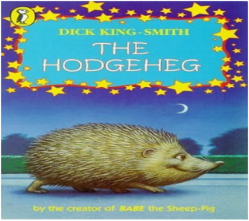
Computing / Online Safety
In Computing, the children will be using data and information to understand the importance of passwords. Our online safety focus this term is well-being and lifestyle.
Mathematics
The children will be exploring place value to 50, Length and Height and Mass and Volume. The children are really enjoying using their rekenreks in Mastery Maths to subitise.
The children will continue to develop their understanding of mathematical vocabulary.

Science –
This half term in Year 1, our focus is animals! We have an exciting animal workshop taking place on Monday, 16th March. A huge thank you to Frogs for their contribution in making this possible.

History –
How would you travel?
RE/PSHE
In RE, the children are extending their knowledge on the question, “Who is Muslim and what do they believe?”
During PSHE, we will be focusing on the topic of being healthy!
REMINDERS
- Healthy nut free snacks at morning break please – (the children do also get fruit)
- PE is on a Wednesday.
- Please ensure that school uniform is labelled.
- Homework will be given out on Thursdays and returned on Wednesdays.
- Read, Write, Inc books are changed on Friday.

DT
“How can we make sure our sandwich is healthy? This term, we will be creating our own healthy sandwich, using the research and design skills we’ve been developing.

History
In History, we will be learning all about transport. We will be focusing on how transport has changed over time, exploring the history of cars, and learning about the Wright brothers, We also have a visit from West Transport lorry, which we’re very excited about.
Dates
Thursday 5th March – World book day
W/C 9TH March – Lorry visit
Monday 16th March – Animal visit
Tuesday 17th March – Trinity Church – Easter Garden
Friday 20th March= Red Nose Day. Non-uniform day to raise money for this good cause.
Friday 27th March – School closes for the Easter break

20
PE
Mr Oliver will take the children for their PE lessons on a Wednesday afternoon. They will be developing their game for understanding skills.

