OVERVIEW OF AUTUMN 2 - Year 1
Mrs Hancock / Miss Darnell / Mrs Strawson

Mrs Fletcher

Year
Yr
YEAR

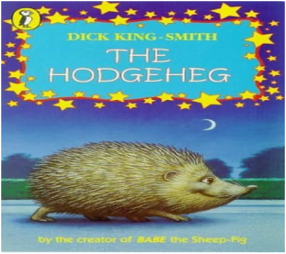
Literacy
The children will be engaging in reading and writing activities based on Farmer Duck, Dogger, and The Christmas Pine.
In Phonics (Read, Write, Inc), the children will be grouped based on their assessment, and will be following either set 1, set 2 or set 3 sounds.

PE
Mr Oliver will take the children for their PE lessons on a Wednesday afternoon. They will be developing their gymnastic skills!

Mathematics
The children will be exploring adding, subtracting, and shapes, while beginning mastery number skills using a rekenrek for deeper understanding.
The children will continue to develop their understanding of mathematical vocabulary.

History
We will be learning about toys, exploring the differences between new and old, placing them on a timeline, and even sharing our favourite toys with our friends.
How have toys changed over time?
Computing / Online Safety
In Computing, the children will be using digital paint to create different shapes and patterns. Our online safety focus this term is self-image and identity.

Science –
This half term in Year 1, our focus is materials—exploring properties, uses, and differences through exciting hands-on investigations.

RE/PSHE
In RE, the children will be learning about Christians and exploring different Bible stories, including Noah’s Ark, the Lost Sheep, the Lost Coin, and many more.
During PSHE, we will be focusing on the topic of bullying—exploring what bullying is and identifying who to talk to if we have a problem.

REMINDERS
- Healthy nut free snacks at morning break please – (the children do also get fruit)
- PE is on a Wednesday.
- Please ensure that school uniform is labelled.
- Homework will be given out on Thursdays and returned on Wednesdays.
- Read, Write, Inc books are changed on Friday.

Art/Design Technology
Our learning challenge is to design and create a pop-up toy inspired by those children played with in the past. We will be researching, exploring ideas, and using our skills to make our very own version.

Dates
W/C 1st December – Book Fair.
Thursday 4th December – Christmas Fair
Friday 5th and Monday 8th December – Christmas Concert
Tuesday 9th December – Trinity Church
Wednesday 17th December
Friday 19th December – Break up

.

