Computing / Online Safety
In Computing, the children will be focusing on programming using vocabulary such as buttons, directions and routes. Our online safety focus this term is copyright and ownership.
Literacy
The children will be engaging in reading and writing activities based on King of the Swamp, The Smart Cookie, and Bumble bear.
In Phonics (Read, Write, Inc), the children will be grouped based on their assessment, and will be following either set 1, set 2 or set 3 sounds. We will be extending our learning on reading comprehensions.

OVERVIEW OF Summer 1 - Year 1
Mrs Hancock / Miss Darnell / Mrs Strawson

Mrs Fletcher

Year
Yr
YEAR

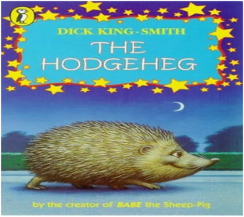
Mathematics
The children will be exploring Length and Height, Mass and Volume and Multiplication. The children are really enjoying using their rekenreks in Mastery Maths to subitise.
The children will continue to develop their understanding of mathematical vocabulary.

Science –
This half term in Year 1, our focus is plants! The children will explore sunflowers by observing their growth, labelling key parts, and planting their own seeds to learn about nature and plant life cycles.

Geography
I wonder why some places in the world are hot and some are cold?

RE/PSHE
In RE, the children will be learning about Judaism, exploring key beliefs and discovering the special celebrations that are important in the Jewish faith.
During PSHE, we will be extending our knowledge being healthy!
REMINDERS
- Healthy nut free snacks at morning break please – (the children do also get fruit)
- PE is on a Wednesday.
- Please ensure that school uniform is labelled.
- Hats for the warm weather.
- Homework will be given out on Thursdays and returned on Wednesdays.
- Read, Write, Inc books are changed on Friday.

Art
The children will explore printing through sponge painting, clay pressing, and creating their own tools to make repeating patterns while developing creativity and fine motor skills.

Geography
The children will compare hot and cold countries by exploring climate, the equator, and key human and physical features, linking their findings to similarities and differences with the UK.

Dates
Friday 1st May – Workshops to start
W/C 11th May – Trinity Church
W/C 18th May – Walk to West Park
Friday 22nd May – Break up
Monday 1st June – Inset day
Look out for more diary dates on Mrs Buxton’s newsletter on WEDUC.

20
PE
Mr Oliver will take the children for their PE lessons on a Wednesday afternoon. They will be developing their striking and fielding skills.

