
Nursery Newsletter Autumn 2

Welcome back to Nursery and the term of Sparkle and Shine! Following on from our learning in the first term we are really excited to begin our Autumn 2 term where we will be learning about bears and enjoying bear stories and we will be preparing for and celebrating our Nativity and all things Christmas!

Meet the Team

Mrs Roberts Mrs Whittaker Mrs Lawson Mrs Gill Miss Wayte
Ready for learning-Kitted for Winter
Our outdoor learning is available to the children throughout everyday. Please ensure they have the correct clothing to access this safely. This includes a warm waterproof coat, hat, gloves and wellies. Please also ensure that everything is clearly labelled with your child’s name, several children have matching drink bottles and coats and it has caused quite a drama at times. 
Snack money
Thank you to those parents who have already paid for snack. The children receive snack every session. This is charged at £1 per week for children who attend part time and £1.50 per week for those who attend full time. It must be paid in cash to a member of the Nursery team. You may choose to pay in half termly or weekly instalments.

Nativity Performances
Our performances are on Wednesday 10th December. If your child does not attend a session on a Wednesday they may join either the morning or the afternoon performance. Ticketing information will be sent out in the next few weeks.

Family photos
We love the “our families” display and your children love to look at their pictures when they are thinking of you and telling their friends about their families. This term we would like you to send or bring in a photo of you enjoying story time or sharing a book at home or with a special person.

Many Thanks, Nursery
Personal Social and Emotional Development  We will be thinking about different feelings and how we can learn to manage them.  We will be continuing to share and take turns with our peers when playing at Nursery.  We will be thinking about bear in the bear hunt story and talking about his feelings. | Communication and Language  We will be learning Christmas different songs and rhymes, some with actions. We will act out our own experiences in a Christmas role play area and talk about any traditions we have. We will be thinking about different festivals and talking about how they differ from the ones we celebrate at home. | Physical Development  This half term we will be continuing to develop our gross (large) and fine (small) motor movements.  In our weekly PE sessions, we will be exploring movement to music.  In the garden we will be continuing to expand on a range of skills, moving safely around obstacles and building and carrying large construction with care. We will begin to think about risk and how we can manage this to ensure the safety of ourselves and our friends. | Literacy  In literacy we will be continuing to practice our early writing skills. We will be working hard on recognising and writing our name.  We will be sharing lots of stories linked to many different topics and enjoy retelling them with our friends, using props and figures to support our storytelling.  We will be thinking carefully about story language and learning lots of new vocabulary.
Autumn 2 - Questions we will be exploring:
What do ears do in winter? What bear stories do we know?
How do people celebrate? What is Christmas?
Characteristics of  Effective Learning  Playing and exploring  Showing curiosity about objects.  Using senses to explore the world.  Engaging in open-ended activities.  Pretending objects are things from their experience.  Representing their experiences in play,  Taking on a role in their play. |  |  | Mathematics  In Maths we will be looking at different numerals. Representing numbers using objects and non-moveable objects. We will be adding and combining amounts, record these as a number sentence.  We will be learning about 2D shapes and their properties.
 | Expressive Arts and Design  We will be exploring a wide range of media. We will be creating firework pictures and paintings and creating rangoli patterns using coloured sand.  We will be making our own Christmas cards and lists, using scissors and glue, then sending these to Santa.  We will be making Christmas decorations to bring home and put on our trees. We will be learning and signing songs and dances for our special concert. | Understanding the World  We will be learning about different animals and their habitats. We will be looking at their markings and how they are similar and different to others.  We will be learning about many different religious festivals such as Diwali, advent and Christmas. We will be talking about our experiences of these celebrations and looking at similarities and differences between these festivals.

Diary Dates
3rd November | INSET Day
4th November | Return To School
11th November | Remembrance day
13th November | Kindness Day – bring a bear to school
14th November | Children In Need – dress up day
21st November | Bear Hunt Welly & Messy day
25th November | Xmas Craft day – non uniform
29th Nov-4th Dec | Book Fair in the library 3.15-4pm
2nd December | Sparkle and shine day-wear something sparkly
4th December | Frogs Fair & Story With Santa 6-8pm
5th December | Christmas Messy day
10th December | Nursery Nativity Performance times coming soon
17th December | Christmas Party
18th December | Pyjama and Movie day
19th December | Christmas Jumper Day
19th December | Last Day For Christmas
4th & 5th January | Inset day
8th January | Welcome Back
Our Story Of The Week
Week 1: 4th-7th Nov  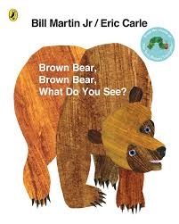 | Week 2: 10th–14th Nov  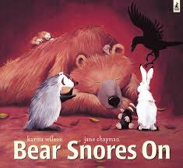 | Week 3: 17th-21st Nov  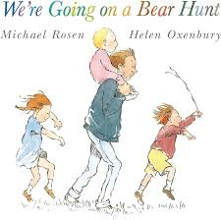
Week 4: 24th–28th Nov  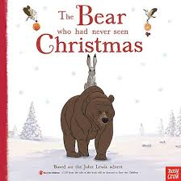 | Week 5: 1st-5th Dec  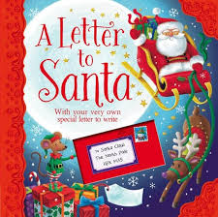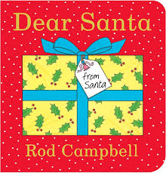 | Week 6: 8th-12th Dec  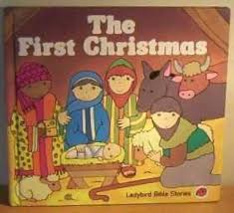
Week 7: 15th-19th Dec
