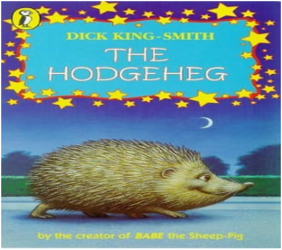
Literacy
This term we will be learning how to write non-chronological reports and biographies to inform a reader. Our SPAG sessions will focus on apostrophes for contraction and possession and the use of pronouns.
Spellings will continue to be tested weekly on a Monday. We will continue to emphasise the importance of presentation and handwriting.
In addition to this, we will be studying a different text every week for our Shared Reading and we will have an explicit Reading Comprehension each week.

Information Technology

During this term, the children will learn about spreadsheets. Using spreadsheets , they will learn how to use software effectively, efficiently and collaboratively.

Maths
This half term we will be developing our knowledge of fractions. Alongside this, we will be extending our understanding of converting units of time. We will continue to revise and improve our arithmetic skills and understanding of mathematical vocabulary.

OVERVIEW OF AUTUMN 2 Year 6
Year
Yr
YEAR

Science
We will be studying the topics on ‘Evolution and Inheritance’.

RE
In RE we will be exploring the five pillars of Islam.. We will gain a greater understanding of Islam and what we can learn from its beliefs, values and ideas. Our learning provides an opportunity to learn about the Qur’an and other forms of guidance.

Why is Climate Change such an important topic?

PE
Mr Oliver will teach the children during PPA time on a Monday afternoon. They will be learning all about gymnastics.

PSHE
In PSHE we will look at what direct, indirect and cyberbullying means. Then we will look at how to Identify when banter or other behaviour becomes unkind. Then we will analyse ways to identify and manage uncomfortable feelings online/offline.

Music
We will be learning a variety of different Christmas concerts in preparation for our concert (date TBC).

Art/Design Technology

The pupils will be creating artwork to encourage people to help reduce climate change as well as finding out more about Keith Haring.

IMPORTANT INFORMATION /DATES
- Children can bring healthy snacks for break time. However, please note that we are moving towards being a nut-free school and so all snacks should be nut-free.
- Homework will be given out weekly on a Tuesday following Tuesday.
- PE day is on a Monday. Children to wear their PE kit to school.
- Library day is a Thursday.
- SATs week 11th – 14th May 2026.
- Isle of Wight residential Monday 15th June to Friday 19th June
- Remember if you have any issues, please feel free to come and see us or contact us via the office.
- Friday 12th December is our carol concert in the afternoon.

Geography
Year 6 will be learning all about climate change and the importance of protecting the planet. They will study the ozone layer and look at why the earth has heated up over the years. We will also learn about the work of Greta Thunberg.

