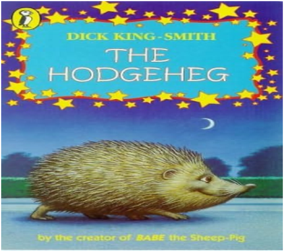
Information Technology
During this term, the children will learn about coding in a variety of programmes. The children will look at how they can create their own games using coding and will use this to make amendments to their creations.
English
This term we will be reading and watching extracts from Macbeth. The children will read and respond to the story via written and spoken forms to develop their comprehension skills. They will be using VCOP knowledge (Vocabulary, Connectives, Openings, Punctuation) to write a diary and newspaper report based upon our topic focus. Spellings will be tested weekly. We will continue to emphasise the importance of presentation and handwriting. In addition to this, we will be studying different aspects of grammar including word classes, homophones and Standard English.

Maths
The children will be developing their knowledge of addition, subtraction, multiplication and division. Alongside this, they will be securing and extending their understanding of place value, fractions, measurement and geometry. The children will continue to revise and improve their arithmetic skills and understanding of mathematical vocabulary.

OVERVIEW OF AUTUMN Year 6
Year
Yr
YEAR

Science
We will be studying the human circulatory system and carrying out investigations involving pulse rate.

Topic
The Tudors
RE
Year 6 will be learning about what it is like be a Muslim in Britain today.

PSHE
Year 6 will be learning about diversity and different families. We will be challenging stereotypes. We will also cover the topic of Being Me.

PE
Mr Oliver will teach the children during PPA time on a Monday afternoon. This term they will be focusing on invasion games.

Art/Design Technology
The pupils will be creating artwork inspired by Macbeth, including making family crests and set designs. We will also be studying self-portraits. Our artist for this half term is Claude Monet. We will looking applying his techniques to our own art.

History / Geography
Year 6 will be studying Elizabethan times and the life of William Shakespeare. We will also be placing the Edwardian period on a time line. Following on from this we will be looking at the influence
William Shakespeare had on our language today.
Music
We are currently looking into buying a new music scheme so will keep you updated on this.

IMPORTANT INFORMATION /DATES
- Children can bring healthy snacks for break time. However, please note that we are a nut-free school and so all snacks should be nut-free.
- Homework and spellings will be given out weekly on a Wednesday and are due back in on a Monday.
- PE day is on a Monday . Children to wear their PE kit to school.
- Library day is a Thursday.
- Parents evenings Tues 20th October and Wed 21st October.
- Monday 2nd November– INSET Day

