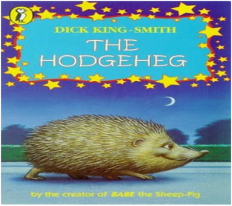
,
Computing
In computing this half term, we will be working on 3D modelling. We will be looking at how computer programmes can aide in our design. We will work to create a range of models that include a maze and discuss how products can be made using 3D printers.
English
This term our topic will be centred around the Isle of Wight. The children will learn how to write a persuasive brochure using literary devices such as the power of three and emotive language. They will move on to creative story writing giving the children a chance for their imaginations to shine through! Spellings will be tested weekly. We will continue to emphasise the importance of presentation and handwriting. In addition to this, we will be studying different aspects of grammar.

Maths
This term in maths we will be continuing to look at fractions, decimals and percentages. We will also be looking at ratio and how this can relate to real life scenarios. As well as this we will be looking at working out the values of unknown numbers by using algebra. This half term we will be working at refining our arithmetic skills through our weekly sessions.
Overview of Spring Term 2: Year 6
Year
Yr
YEAR

Science
We will be looking at the topic
of Evolution and Inheritance. Children will recognise that living things produce offspring, identify how animals and plants are adapted to suit their environment and will learn about the theory of evolution.

Why is the Isle of Wight such a popular tourist destination?

RE/PSHE
We will be looking at the topics of:

RE – Is it better to express your religion in arts and architecture or in charity and generosity?
PSHE – Drug Education
Art
We will be looking at paintings of the Isle of Wight done by resident artists and will use watercolours, pastels and chalks to recreate these.
PE
Mr Oliver will teach the children PE during PPA time on a Monday afternoon. They will be working on orienteering and team building.

Geography
We will describe how some places are similar and others are different in relation to their human and physical features. We will compare Nottingham to the Isle of Wight.
We will locate the IOW using 6 figure grid references and explain why certain physical features make for popular tourist destinations.

Music
Mrs Wardle will teach the children music during PPA time on a Monday afternoon. They will be working on Music Express.

IMPORTANT INFORMATION
- Homework will be given out weekly on a Wednesday and is due back in on a Monday.
- Spellings will be given out on a Wednesday and tested the following Monday..
- World Book Day – Thursday 5th March
- Book fair – 5.3.26 – 10.3.26
- SATs week 11th – 15th May 2026.

Mr Gooch and Mr Palfreyman

