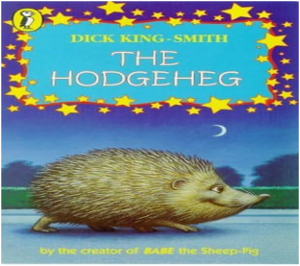
,
Science
We will be looking at the topic
of light. We will be learning to understand the nature of light, how it travels in a straight line and that light can be reflected and refracted. We will be looking at how white light can be separated into different colours using prisms and we will investigate the nature of shadows too.
Maths
This term in maths we will be learning in more depth about angles. This includes angles on a straight line and right angles, plus the nature of angles inside triangles, rectangles and other shapes. We will study the internal properties of circles too. We will also study position and direction, including plotting shape co-ordinates on a grid, reflecting and translating these positions into different quadrants.
English
Our English curriculum this half term will be heavily focused on the skills of reading and SPAG initially, as we prepare our children for the up-coming SATs week in May. We will be investigating a wide variety and length of texts, including all genres of fiction, non-fiction and poetry. SPAG will include an in-depth study of all the various elements of English grammar, revising all concepts covered over the previous years of learning. Writing will be topic- based, and we shall be sharing our understanding of the Mayan civilisation in the form of a report.

Overview of Summer Term 1: Year 6
Year
Yr
YEAR

RE/PSHE
We will be looking at the topics of:

RE – How does religion help us when times get hard?
PSHE – Discovering personal strengths and talents; online safety.
Who were the Mayans and what have we learned from them?
PE
Mr Oliver will teach the children PE during PPA time on a Monday afternoon. They will be working on rounders, throwing and catching skills.

IMPORTANT INFORMATION
- Homework will be CGP revision booklet focused this half term. Each week, the children will have 3 short pieces of homework, one SPAG, one reading and one maths- see the timetable in the children’s booklets for details each week.
SATs week 11th – 15th May 2026,
Monday 11th- Spelling, punctuation and grammar (SPAG). Tuesday 12th- Reading
Wednesday 13th- Maths Arithmetic and Reasoning 1. Thursday- Reasoning 2.
Mr Gooch and Mr Palfreyman

History
The ancient civilisation of the Mayans is our driver this half-term. We will study their history, culture, geography and significance on an international level.

We shall study the modern-day countries where the Mayan civilisations once were and understand how they influenced the entire Central American area. We shall understand how they celebrated religion, sport and culture and we shall see how they invented and adapted writing and number systems to suit their culture.
Music
Mrs Wardle will teach the children music during PPA time on a Monday afternoon. They will be working on Charanga.

