

**Grange Primary School Uniform Policy**

Our uniform policy reflects our values and reinforces our school’s culture of high expectations and academic achievement. All pupils must dress according to the Uniform Policy. Our school uniform is important to us. It is one way in which we identify ourselves as a school community and it promotes a strong and cohesive school identity which supports high standards in all areas of school life. It promotes harmony between different groups represented in the school and enhances security. When a pupil puts on a school uniform they are representing the Grange values and are upholding these within our local community, wearing them with pride.

**Uniform Details**

**Reception, Key Stage 1 and Key Stage 2**

Burgundy sweatshirt, fleece or cardigan

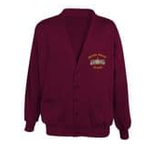

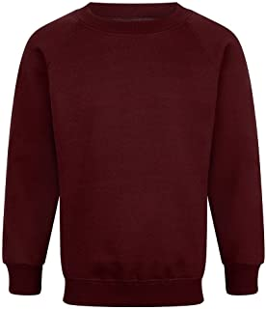

Black/Grey skirt, black/ grey dress, or black/ grey trousers

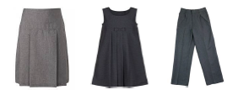

White shirt or white/yellow polo shirt

In warmer weather, children may wear:

Red, yellow or burgundy summer dresses Grey/ black shorts with white/ yellow shirt or polo

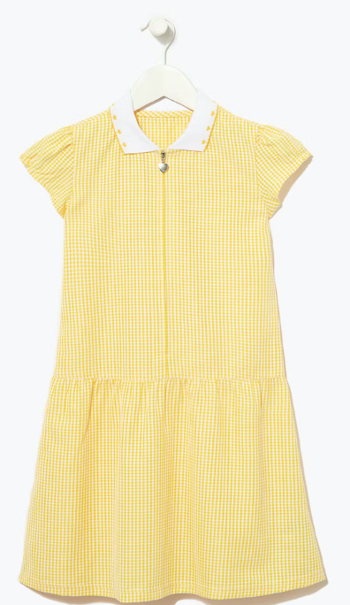

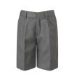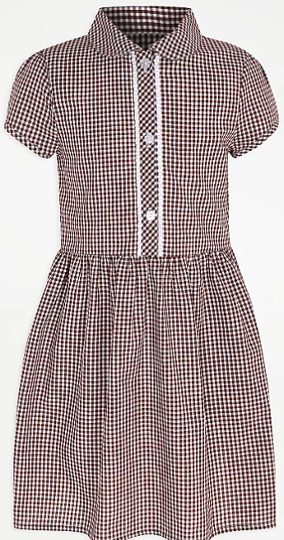

**Reception, Key Stage 1 & Key Stage 2- PE Kit**

Yellow top Burgundy Shorts Plain black track suit bottoms with no logos

These can be worn with the Grange school jumper, cardigan or fleece. PE kits form part of our school identity when we go out into the community to compete in tournaments, take part in workshops or visit other schools. They help both for identification purposes as well as our sense of togetherness. When pupils wear these, they are part of our Grange Sports Team we expect them to uphold our Grange values diligently, work together and wear our badge with pride.

**Footwear**

Pupils must wear closed-toed, hard-soled, all black plain shoes with a flat sole. Footwear with flashing lights is not appropriate for school. All black or all white closed-toed plimsolls can be worn in the summer (Easter – end of summer term). Trainers/plimsolls to be worn with the school PE kit.

Footwear guide *(for illustrative purposes only)*

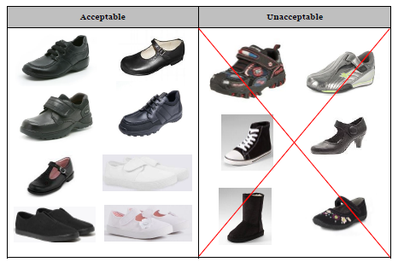

**General**

**Outdoor clothing**

Children should bring a coat to school each day, apart from during warmer weather.

**Bags and belongings**

A high visibility bookbag or backpack with the Grange logo is recommended for carrying books, homework, letters, and other materials to and from school.

**Hats, Headscarves or Headwear**

Pupils are not allowed to wear hats, headscarves, or any other head covering inside the school building unless it is due to religious or cultural values.

**Hairstyles**

Long hair should be tied back neatly in PE. Extreme hairstyles that would cause a disruption to learning are not permitted.

**Fingernail Polish or Make-Up**

Pupils are not allowed to wear fingernail polish or false nails. Make-up is not allowed.

**Jewellery/Accessories**

Pupils may not wear any jewellery except for one watch only (no smart phone watches, sound effects or games). Pupils are allowed to wear one pair of stud earrings. All studs must be removed for PE.

*Please note that the school will be unable to take any responsibility for any watches or* jewellery that are lost.

**Naming Clothing and Property**

**VERY IMPORTANT** – Please ensure all clothing and property is clearly marked so that lost articles may be easily traced and returned. The school cannot accept responsibility for loss or damage of pupils’ property and valuables.

**Lost Property**

All mislaid items are placed in the lost property box located in the foyer at the school office. Please ask the school office if you wish to look through this. We endeavour to return all named property.

**Pre-loved Uniform**

Any unwanted items of uniform may be given to FROGS who can be contacted via the FROGS facebook page or through the school office ready to be resold. Families who would like to utilise this service and purchase pre-loved uniform can contact the school office who are happy to help facilitate this with the Frogs team.

**Pupil premium free items of uniform**

It is also school policy, that if your child receives Pupil Premium funding (Free School Meals) you will be provided with either a sweatshirt/cardigan and a school PE top for free as part of this provision. This will always be processed towards the end of the summer term each year. Families will be contacted directly in order to provide correct sizing.

**Racial Equality & Equal Opportunities**

All children have equal access to wearing school uniform regardless of their culture, race, religion, gender, disability or ability. We ensure that the set uniform respects other policies such as race relations, sex discrimination and allows for individual sets of circumstances of all groups and individuals. Grange Primary is committed to creating a positive climate that will enable everyone to work free from racial intimidation and harassment and to achieve their full potential.

**Supporting the school’s uniform policy**

Polite reminders will be given by class teachers in the first instance, if your child is not fully compliant with the school uniform policy. Please let your class teacher know if there is a very valid reason why your child is not in full school uniform, we always work together with our families with regards to this.

A member of the Senior Leadership team at Grange will contact you if school uniform continues to be an issue for your child.

Reviewed Summer Term 2023 by the board of governors at Grange Primary School.