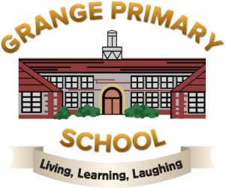

Issued May 2025

SCHOOL HOLIDAYS

School closes on School re-opens

Mid-term Friday 23rd May 2025 Tuesday 3rd June 2025

Summer Wednesday 23rd July 2025 Monday 8th September 2025

Mid-term Friday 24th October 2025 Tuesday 4th November 2025

Christmas Friday 19th December 2025 Tuesday 6th January 2026

Mid-term Friday 13th February 2026 Monday 23rd February 2026

Easter Friday 27th March 2026 Monday 13th April 2026

May Day Friday 1st May 2026 Tuesday 5th May 2026

Mid-term Friday 22nd May 2026 Tuesday 2nd June 2026

Summer Thursday 23rd July 2026 TBC

STAFF TRAINING DAYS – no children in school:

Monday 2nd June 2025
Thursday 24th July 2025

New School Year

Thursday 4th September 2025
Friday 5th September 2025
Monday 3rd November 2025
Monday 5th January 2026
Monday 1st June 2026

PLEASE DESTROY ANY PREVIOUS HOLIDAY LIST

